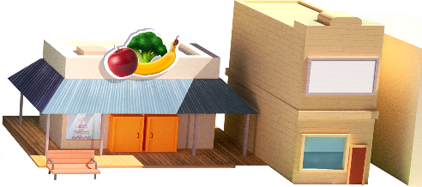
App 7: The Polyglots in the Town
Supermarket
English; Drama
Give students a range of shop items for setting up a mini supermarket, such as cereal boxes, toy fruits and vegetables and drink containers. Students take it in turns to be shopkeeper or customer. Encourage them to use the target language when requesting items. The shopkeeper listens to the customer’s order, places the item into their shopping basket, and then requests payment. Revision language from some of the earlier apps, such as ‘thank you’ and ‘goodbye’, can also be used in this activity.
Australian Curriculum links (Foundation): ACELY1646 and ACADRM027
Visual Arts
Provide students with a collection of supermarket catalogues and explore their features together. You may like to provide a template for students to use to create their own catalogues or they could create their own from scratch. When completed, the students’ catalogues can then be used as part of the classroom shopping experience.
Australian Curriculum links (Foundation): ACAVAM108
English
Students practise writing shopping lists using the target language. As a whole class, model writing a shopping list containing various food items. The ‘Make a cake’ ingredients printable (App 3), the ‘Fruit bingo game’ printable (App 4) or the food items in the ‘Supermarket shopping game’ printable (App 7) are useful references. Students write /copy/ trace a number of items onto their shopping list and then visit the classroom supermarket to ‘purchase’ their items.
Australian Curriculum links (Foundation):
ACELY1651
English
Using the ‘supermarket shopping game’ printable, prepare enough sets for your students to play together in small groups. Encourage students to use the target language when playing. You may also like to include other food items from the earlier apps, using the ‘Make a cake’ ingredients printable (App 3) or the Fruit bingo game printable (App 4).
Australian Curriculum links (Foundation): ACELY1646
Learning intentions: We are learning how to say the names of some supermarket items in________ (language).
Success criteria: I can name some supermarket items in ________ (language).
Resources: App 7, App 7 guide, ‘Make a cake’ ingredients printable (App 3), the ‘Fruit bingo game’ printable (App 4), ‘Supermarket shopping game’ printable, toy cash register, supermarket play items, a collection of supermarket catalogues, A4 paper, art materials
Assessment opportunities: The apps have been developed with subject matter experts. They are aligned to and support the learning outcomes of the Australian Curriculum: Languages for F–2.
You can find specific links to the Australian Curriculum for your language on the ELLA website, in the Educator Zone App Toolkit.





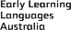

ELLA is funded by the Australian Government Department of Education, Skills and Employment and is managed by Education Services Australia. © 2021 Commonwealth of Australia, unless otherwise indicated. This material, other than Commonwealth trade marks in The Polyglots characters and The Polyglots logo, may be used in accordance with the Creative Commons BY-NC 4.0 licence unless otherwise indicated.

