
App 2: The Polyglots at the Beach
Feed the fish
Learning intentions: We are learning to identify and say the names of coloured fish in ________ (language).
Success criteria: I can identify and say the names of coloured fish in ________ (language).
Resources: App 2, App 2 guide, coloured fish printable, metal paperclips, rods, magnets, craft materials (such as crayons, paint, fabric), A3 paper
Drama
Create a play area where students can re-enact aspects of the ‘Feed the fish’ experience. Set up a ‘pool’ (bucket, container or box) and place all the fish from the coloured fish printable inside it, each with a metal paperclip attached. Students then ‘go fishing’, using a rod with a magnet on the tip. They attempt to catch fish of the colour called out by a student playing the role of Tam.
Australian Curriculum links (Foundation): ACADRM027

English
Organise students into pairs or small groups to play a game of Memory using the coloured fish printable. Encourage students to practise using the target language for the colours of the fish as they find matching pairs.
Australian Curriculum links (Foundation): ACELY1646

Visual Arts
Selecting from a range of craft materials (such as crayons, paint, fabric piece), students design and create their own coloured fish to be displayed on posters. They can trace/copy/write the name of the coloured fish under each creation.
Australian Curriculum links (Foundation): ACAVAM107
Science
Generate a class discussion about the many different types of fish. What do students already know? Discuss the differences between freshwater fish and saltwater fish. Provide various images and some interesting facts. Students can then illustrate some of these different fish types in their books.
Australian Curriculum links (Foundation): ACSSU002
Assessment opportunities: The apps have been developed with subject matter experts. They are aligned to and support the learning outcomes of the Australian Curriculum: Languages for F–2.
You can find specific links to the Australian Curriculum for your language on the ELLA website, in the Educator Zone App Toolkit.
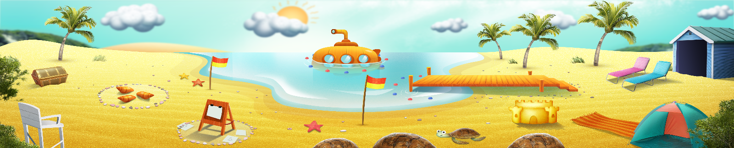


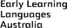

ELLA is funded by the Australian Government Department of Education, Skills and Employment and is managed by Education Services Australia. © 2021 Commonwealth of Australia, unless otherwise indicated. This material, other than Commonwealth trade marks in The Polyglots characters and The Polyglots logo, may be used in accordance with the Creative Commons BY-NC 4.0 licence unless otherwise indicated.

