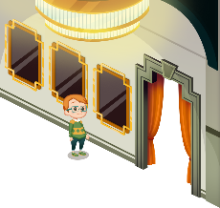
App 11: The Polyglots at the Concert
Design a poster
Learning intentions: We are learning to say the days of the week and how to tell the time in ___________________ (language).
Success criteria: I can say the days of the week and how to tell the time using _____________ (language).
Resources: App 11, App 11 guide, blank calendar template, A3 paper, coloured paper, scissors, glue, costume items/dress-ups.
Mathematics
The Design a poster experience contains the language for the days of the week. As a class, talk about the days in a week, month and year. Discuss the purpose of calendars. Then, using a blank calendar template, encourage students to work in pairs to identify each day of any given month and then trace/copy/write the days using the target language.
Australian Curriculum links (Year 2):
ACMMG041

English; Visual Arts
Using A3 paper, students can design and create their own poster for a concert performance. Encourage students to use the target language to include the phrases ‘What day?’, ‘What time?’ and the chosen responses for the days of the week and the time of the show as demonstrated in the activity.
Australian Curriculum links (Year 2):
ACELY1671 and ACAVAM108

English; Drama
In pairs or small groups, students can create their own concert performance based upon the performers within this activity. Students may like to recreate the cultural performance with props and costumes.
Australian Curriculum links (Year 2):
ACELY1666 and ACADRM028

English; Drama
The Design a poster experience includes a cultural performer from a country where the language is spoken. As a whole class, spend time discussing and, if possible, viewing an online cultural performance. What message are the characters conveying? How do they communicate this message? Discuss different kinds of spoken, non-verbal, written and visual communication.
Australian Curriculum links (Year 2):
ACELA1460 and ACADRR030
Assessment opportunities: The apps have been developed with subject matter experts. They are aligned
to and support the learning outcomes of the Australian Curriculum: Languages for F–2.
You can find specific links to the Australian Curriculum for your language on the ELLA website, in the
Educator Zone App Toolkit.

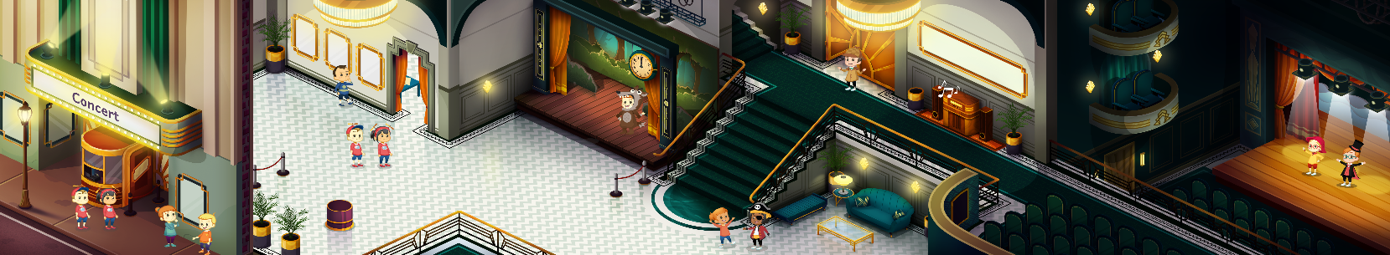


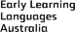

ELLA is funded by the Australian Government Department of Education, Skills and Employment and is managed by Education Services Australia. © 2021 Commonwealth of Australia, unless otherwise indicated. This material, other than Commonwealth trade marks in The Polyglots characters and The Polyglots logo, may be used in accordance with the Creative Commons BY-NC 4.0 licence unless otherwise indicated.

