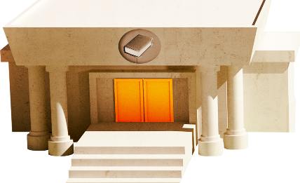
App 7: The Polyglots in the Town
Library
English
Print a class set of the ‘Friends book’ printable so that each student can complete one. Talk about each phrase together and then encourage students to trace over the target language. Encourage students to share their completed booklets with a friend.
Australian Curriculum links (Foundation): ACELY1645
English
Students create their own mini-book about their time visiting the Polyglots in the town. Discuss what students noticed there – what buildings did they see? What conversations did they hear? List these things on the board, adding the target language where possible. Give each student a piece of white A4 paper, folded to create four pages. Assist them to write/copy/trace the target language words and phrases as needed. An example mini-book might be: page 1 (cover): In the town; page 2: Pizza café; page 3: Supermarket; and page 4: Library.
Australian Curriculum links (Foundation): ACELY1651
Learning intentions: We are revising some of our new words in ________ (language) learnt from our experience with the ELLA apps.
Success criteria: I can demonstrate my knowledge of ________ (language) that I have learnt from the ELLA apps.
Resources: App 7, App 7 guide, ‘Friends book’ printable, A4 paper, art materials including natural items (for example, twigs, leaves)
Visual Arts
Students create their own artwork of the App 7 playspace. Encourage students to use a variety of art materials including natural items such as twigs and leaves. When the artwork is finished, students could share various features of their work in pairs (maybe with a friend) or in small groups.
Australian Curriculum links (Foundation): ACAVAM107 and ACAVAM108
Visual Arts
Each book in the Library experience provides the opportunity for students to revise language learnt in previous apps. Using A3 paper, students illustrate their favourite app scene and include some of the target language in their artwork. Encourage students to share the language they have learnt from their favourite ELLA app.
Australian Curriculum links (Foundation): ACAVAM108
Assessment opportunities: The apps have been developed with subject matter experts. They are aligned to and support the learning outcomes of the Australian Curriculum: Languages for F–2.
You can find specific links to the Australian Curriculum for your language on the ELLA website, in the Educator Zone App Toolkit.


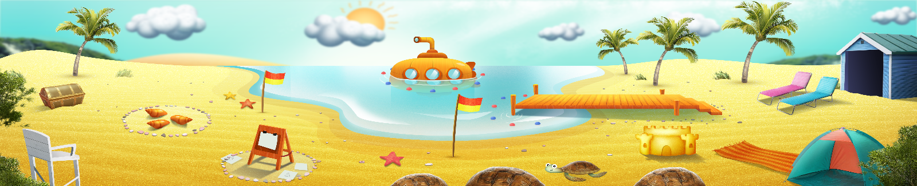


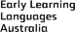

ELLA is funded by the Australian Government Department of Education, Skills and Employment and is managed by Education Services Australia. © 2021 Commonwealth of Australia, unless otherwise indicated. This material, other than Commonwealth trade marks in The Polyglots characters and The Polyglots logo, may be used in accordance with the Creative Commons BY-NC 4.0 licence unless otherwise indicated.

