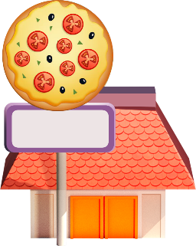
App 7: The Polyglots in the Town
Pizza cafe
Health and Physical Education
Play a modified game of ‘fruit salad’. Have students form a circle in the middle of a basketball court or similar space. Organise them into four groups, each with the name of a pizza topping in the target language. Set a special place for each group around the edges of that space. Tell students that when they hear you call their pizza topping, they should move (run/skip/jump, as appropriate) to that place. When you call ‘Pizza!’, they must hurry back into the middle of the space – the ‘pizza tray’.
Australian Curriculum links (Foundation): ACPMP009 and ACPMP012

English; Drama
Students work together to role-play and create their own pizza restaurants. Give students a range of ‘pizza topping’ materials (e.g. yellow paper to cut into strips for the grated cheese; supermarket catalogues with images of food items that can be cut out and added, cardboard or thicker paper to cut into pizza bases). Students take it in turns to be customer and pizza maker. The customer places an order using the target language. The pizza maker listens to the order and then makes the pizza using the requested ingredients.
Australian Curriculum links (Foundation): ACELY1646 and ACADRM027
English
Using the ‘Pizza activity’ printable, print out enough copies of the ingredient cards for your students to play various games such as memory, bingo or snap. Encourage students to practise saying the names of the pizza toppings using the target language as they play.
Australian Curriculum links (Foundation): ACELY1646
Mathematics
Students design and create a ‘shapes pizza’ with ingredients cut into various 2D shapes. Encourage students to name these shapes. For an extension activity, explore the concept of ‘sharing equal parts’ by demonstrating how a circle can be cut into halves and (if appropriate) quarters.
Australian Curriculum links (Foundation): ACMMG009
Learning intentions: We are learning how to say the names of various pizza toppings using ________ (language).
Success criteria: I can say the names of various pizza toppings in ________ (language).
Resources: App 7, App 7 guide, ‘Pizza activity’ printable, coloured paper, cardboard or thicker paper, a toy cash register
Assessment opportunities: The apps have been developed with subject matter experts. They are aligned to and support the learning outcomes of the Australian Curriculum: Languages for F–2.
You can find specific links to the Australian Curriculum for your language on the ELLA website, in the Educator Zone App Toolkit.
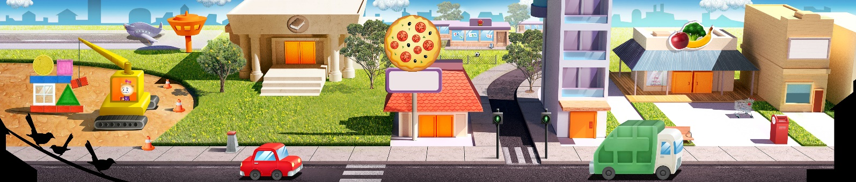

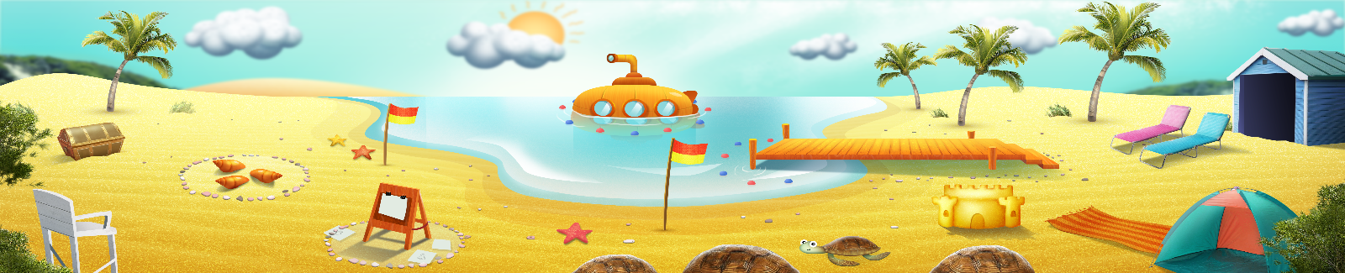


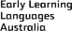

ELLA is funded by the Australian Government Department of Education, Skills and Employment and is managed by Education Services Australia. © 2021 Commonwealth of Australia, unless otherwise indicated. This material, other than Commonwealth trade marks in The Polyglots characters and The Polyglots logo, may be used in accordance with the Creative Commons BY-NC 4.0 licence unless otherwise indicated.

