
App 4: The Polyglots at the Zoo
Juice bar
Learning intentions: We are learning to say the names of some fruit and describe their colours in ________ (language).
Success criteria: I can name some fruits and say their colours in ________ (language).
Resources: App 4, App 4 guide, (optional) pre-cut pieces of different fruits and safe wooden sticks to create edible fruit snacks, toy-fruit counters, A3 paper that you have pre-printed with a tracing-font heading.
Assessment opportunities: The apps have been developed with subject matter experts. They are aligned to and support the learning outcomes of the Australian Curriculum: Languages for F–2.
You can find specific links to the Australian Curriculum for your language on the ELLA website, in the Educator Zone App Toolkit.
Visual Arts
Students design and label their own fruit bowl. Using an A3 piece of white paper that you have pre-printed with the heading ‘My <insert name of language> Fruit Bowl’ in large tracing font, students draw a bowl filled with the fruits of their choice and write/copy/trace the names of the fruits (and their colours) in the target language.
Australian Curriculum links (Foundation): ACAVAM108
Health and Physical Education
Generate a discussion about healthy food. What is the difference between ‘sometimes’ food and ‘always’ food? Talk about fruit in particular. If it is appropriate for your students, give them an opportunity to make their own healthy snacks by creating fruit sticks with different pieces of pre-cut fruit. Encourage students to describe the fruit they used, in the target language.
Australian Curriculum links (Foundation): ACPPS006
English
Recount the sequence of events and list the phrases used in the ‘Juice bar’ learning experience. What happened first? What happened next? Using A3 paper ruled into three sections, students illustrate the events in order and write/copy/trace some of the phrases. For example, Section 1 may include an illustration of the camel requesting a particular juice and the phrase in the target language, Section 2 may include an image of the juice being blended, and so on.
Australian Curriculum links (Foundation): ACELY1651
English
Using the lyrics from the App 4 guide and the MP3 version of the App 4 song, teach and practise singing the song, ‘Fruits’ as a whole-class activity. Students use the names of the fruit and learn the phrases such as ‘I’d like an apple, please’. Encourage them to practise using these phrases in other school contexts such as ordering items from the school canteen.
Australian Curriculum links (Foundation): ACELT1579 and ACELY1784
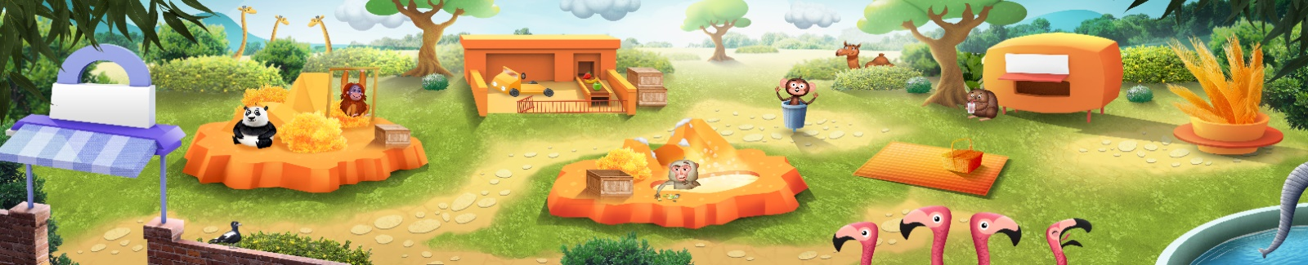
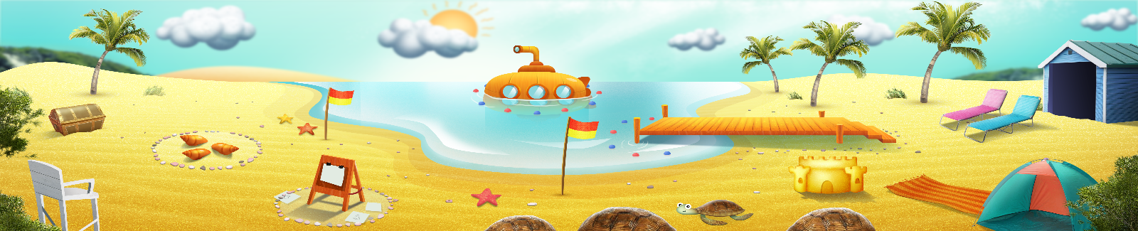


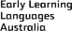

ELLA is funded by the Australian Government Department of Education, Skills and Employment and is managed by Education Services Australia. © 2021 Commonwealth of Australia, unless otherwise indicated. This material, other than Commonwealth trade marks in The Polyglots characters and The Polyglots logo, may be used in accordance with the Creative Commons BY-NC 4.0 licence unless otherwise indicated.

