
App 6: The Polyglots at the Park
Movie builder
Learning intentions: We are learning that stories can be told as storylines in comic strips and movies using pictures and/or sound alone or both, that movies have changed over time, and that instructions follow a linear pattern.
Success criteria: I can sequence events in a story and use ________ (language) in a short movie that I make with others.
Resources: App 6, App 6 guide, A3 paper folded into six, various dress-ups items.
English; Mathematics
As a class, watch App 6’s cultural game video and brainstorm Australian school students’ popular games. Students then vote for their favourite one. Together, represent the response results as a simple bar graph. Note the most popular game, and discuss its rules, equipment and number of players. Return to the app’s cultural game. As a class, write a basic procedural text for someone who is new to the game, using illustrations to aid the explanation.
Australian Curriculum links (Foundation): ACELY1651 and ACMSP011

Assessment opportunities: The apps have been developed with subject matter experts. They are aligned to and support the learning outcomes of the Australian Curriculum: Languages for F–2.
You can find specific links to the Australian Curriculum for your language on the ELLA website, in the Educator Zone App Toolkit.
English; Visual Arts
Students create their own comic strip about Polyglots characters. Give each of them a piece of white A3 paper divided into six rectangles. Explain that each of the six represents a different stage of the comic. Encourage students to include aspects from the app in their story; for example, the Polyglots characters running in a park. See the App 6 guide page 7 for relevant phrases such as ‘Dance fast’ that can be copied or traced and used in students’ comics.
Australian Curriculum links (Foundation): ACELY1651 and ACAVAM108
English; Drama; Digital Technologies
Have students working in pairs or small groups to create their own short movie using the recording feature of the device you use for ELLA. Students can incorporate phrases learnt from earlier apps and dress in costumes. They can take it in turns to be ‘the movie director’ to film their short movies. When finished, students can share their short movies with the rest of their class.
Australian Curriculum links (Foundation): ACELY1784, ACADRM029 and ACTDIK001
English; History
Explore the history of ‘moving pictures’ – later called ‘the movies’. Investigate and discuss some of their early forms and the fact that they were without sound. How were stories (storylines) conveyed? As a whole class, you could look at suitable snippets of movies through time, and then generate a timeline to show the changes in movies over time.
Australian Curriculum links (Foundation): ACELY1646 and ACHASSK013
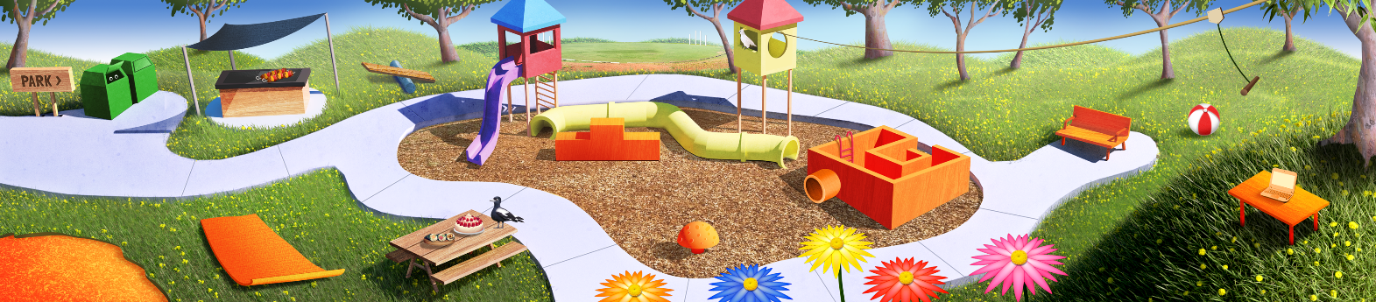

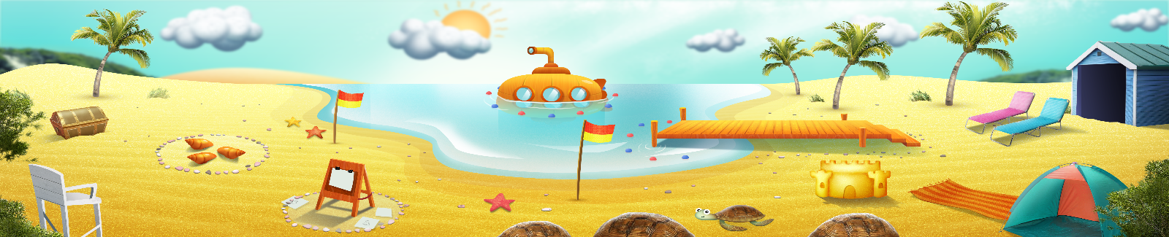


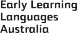

ELLA is funded by the Australian Government Department of Education, Skills and Employment and is managed by Education Services Australia. © 2021 Commonwealth of Australia, unless otherwise indicated. This material, other than Commonwealth trade marks in The Polyglots characters and The Polyglots logo, may be used in accordance with the Creative Commons BY-NC 4.0 licence unless otherwise indicated.

