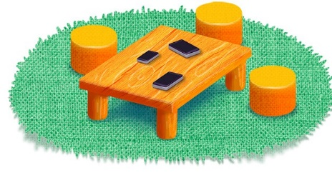
App 1: The Polyglots in the Playroom
Phone
Learning intentions: We are learning to recognise and say the word ‘hello’ in _______ (language).
Success criteria: I can say hello and introduce myself in _______ (language).
Resources: App 1, App 1 guide, toy phones, world map
English
Students illustrate themselves with a Polyglots character having a conversation on the phone. They can write/copy/trace ‘Hello’ in the target language in speech bubbles.
Australian Curriculum links (Foundation):
ACELY1645

English; Humanities and Social Sciences
Generate a whole-class discussion about the places in the world that we come from. Extend this to the wider school community by having a map of the world displayed and asking a family member to place a pin on their country with a note for the word ‘Hello’.
Australian Curriculum links (Foundation): ACELY1646, ACHASSK011 and ACHASSK014

English; Visual Arts
Using the information collected from the previous activity, students design and create different ‘Hello!’ posters by choosing a multicultural greeting to copy/trace/write and decorate for a whole-class display.
Australian Curriculum links (Foundation): ACELA1434, ACELY1651, and ACAVAM108
English
Set up a ‘phone table’ in your classroom for conversational play-based learning experiences. Encourage students to use the target language for communicating with their classmates while they play with the phones.
Australian Curriculum links (Foundation):
ACELY1646
Assessment opportunities: The apps have been developed with subject matter experts. They are aligned to and support the learning outcomes of the Australian Curriculum: Languages for F–2.
You can find specific links to the Australian Curriculum for your language on the ELLA website, in the Educator Zone App Toolkit.

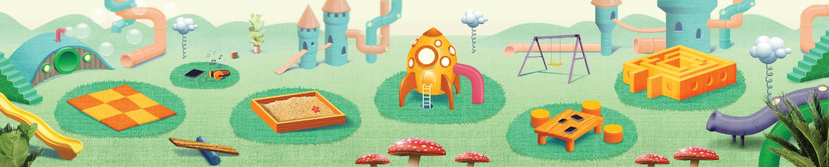


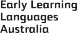
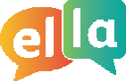
ELLA is funded by the Australian Government Department of Education, Skills and Employment and is managed by Education Services Australia. © 2021 Commonwealth of Australia, unless otherwise indicated. This material, other than Commonwealth trade marks in The Polyglots characters and The Polyglots logo, may be used in accordance with the Creative Commons BY-NC 4.0 licence unless otherwise indicated.

