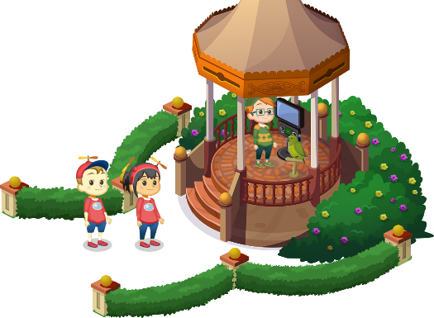
App 10: The Polyglots at the Pet Park
Bird trainer
Learning intentions: We are learning how to respond to the question ‘What is it?’ in ___________________ (language).
Success criteria: I can ask ‘What is it?’ and provide a response in ___________________ (language).
Resources: App 10, App 10 guide, A3 paper, A4 paper, scissors, glue, pictures of animals, craft materials
English; Visual Arts
Students can create their own books using target language for the question ‘What is it?’ Students can trace/copy/write the phrase on each page and illustrate an animal. Students may like to draw on their knowledge from earlier apps and include other images such as fruit (App 4) or school items (App 8). Then another piece of paper is stuck over the image and serves as a flap, under which the mystery image is revealed.
Australian Curriculum links (Year 2): ACELY1671 and ACAVAM108

English; Visual Arts; Design and Technology
The Bird trainer activity contains an image of a cultural animal from the country where this language is spoken. Generate a whole-class discussion about the types of animals that can be found in this country and the different types of habitats. Students may like to illustrate one of these animals in their habitats or alternatively, they could build a diorama of a habitat for an animal of their choice.
Australian Curriculum links (Year 2): ACELY1789, ACAVAM108 and ACTDEP007

English; Drama
In pairs or small groups, students can take it in turns to role-play different animals as seen from the Bird trainer learning experience. The other student(s) need to ask ‘What is it?’ using the target language.
Australian Curriculum links (Year 2): ACELY1666 and ACADRM028

Assessment opportunities: The apps have been developed with subject matter experts. They are aligned
to and support the learning outcomes of the Australian Curriculum: Languages for F–2.
You can find specific links to the Australian Curriculum for your language on the ELLA website, in the
Educator Zone App Toolkit.

English
The Bird trainer activity contains the phrase ‘What is it?’ and the associate response; ‘It’s a ___.’ Provide a series of cards with the pet words in the target language. Students can take it in turns to take a card without showing anyone and ask their partner or small group ‘What is it?’ Others begin to guess the animal as soon as the student begins to draw. ‘Is it a dog?’ They drawer responds, ‘Yes it’s a dog.’ or ‘No it’s a cat.’ in the target language.
Australian Curriculum links (Year 2): ACELY1666

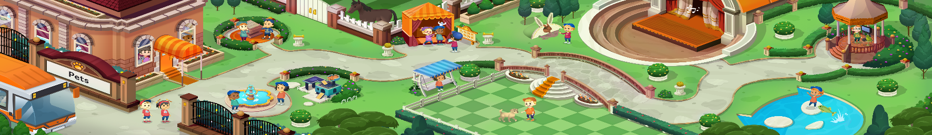




ELLA is funded by the Australian Government Department of Education, Skills and Employment and is managed by Education Services Australia. © 2021 Commonwealth of Australia, unless otherwise indicated. This material, other than Commonwealth trade marks in The Polyglots characters and The Polyglots logo, may be used in accordance with the Creative Commons BY-NC 4.0 licence unless otherwise indicated.

