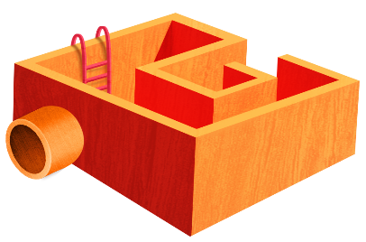
App 6: The Polyglots at the Park
Obstacle maze
Learning intentions: We are learning how to use verbs to give instructions using ________ (language).
Success criteria: I can use verbs to give instructions in ________ (language).
Resources: App 6, App 6 guide, ‘Action dice and poster’ printable, A3 paper, Polyglots you have already created by greatly reducing the size of characters from the ‘Character artwork’ printable and sticking them to icy-pole sticks, building blocks, various craft materials such as cardboard boxes and icy-pole sticks, and items of PE equipment such as hula hoops if required
Health and Physical Education
Play a version of Octopus. Line all students up along one end of an outdoor play area. Choose one or two students to be ‘It’. They are to call out instructions using a verb such as ‘Run!’, ‘Hop!’, ‘Jump!’ in the target language. The rest of the class must repeat this verb and then perform the action to reach the play area’s opposite end. Those caught by the taggers must stay in their spot but reach out to catch moving classmates. When students reach the other end of the play area, a new verb is called out. The game repeats, ending when everyone has been caught.
Australian Curriculum links (Foundation): ACPMP009
English; Visual Arts
Encourage students to design their own 2D maze. Using A3 paper, students work in pairs to draw different obstacles in their maze. They also show parts of it where a particular action must occur by putting a sign there with an instruction such as ‘Jump!’ written in the target language. Students could write, copy or trace the word(s). The ‘Action dice and poster’ printable may assist with this task.
Australian Curriculum links (Foundation): ACELY1651 and ACAVAM108
Design and Technology
Encourage students (in pairs) to build an obstacle maze using building blocks and/or craft materials such as cardboard boxes and icy-pole sticks. The students in the pair then take turns to re-enact the ‘Obstacle maze’ learning experience. One sets the action signs around the maze for the other to respond to with the pre-constructed Polyglots character resource (picture stuck on an icy-pole stick).
Australian Curriculum links (Foundation): ACTDEK003
Health and Physical Education
Extend the concept of this experience into a PE lesson in the school playground. Create a course for students to complete using various movements, and give all instructions using the target language. You may like to provide additional equipment to support the verbs – for example, hula hoops for students to jump into.
Australian Curriculum links (Foundation): ACPMP008
Assessment opportunities: The apps have been developed with subject matter experts. They are aligned to and support the learning outcomes of the Australian Curriculum: Languages for F–2.
You can find specific links to the Australian Curriculum for your language on the ELLA website, in the Educator Zone App Toolkit.
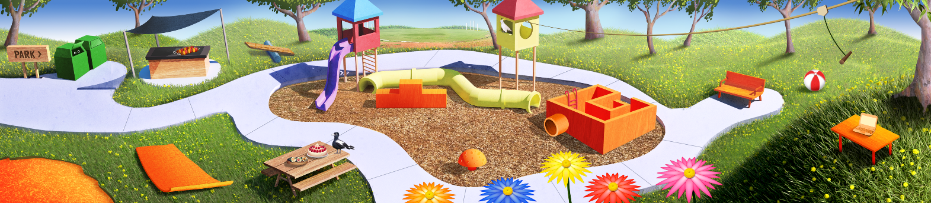

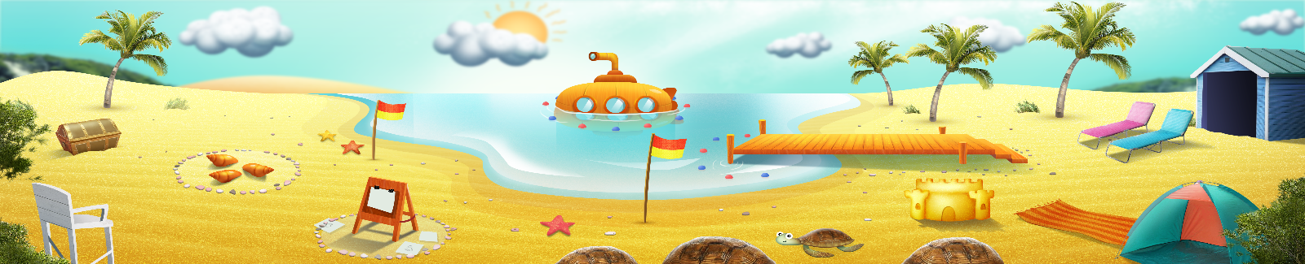


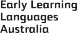

ELLA is funded by the Australian Government Department of Education, Skills and Employment and is managed by Education Services Australia. © 2021 Commonwealth of Australia, unless otherwise indicated. This material, other than Commonwealth trade marks in The Polyglots characters and The Polyglots logo, may be used in accordance with the Creative Commons BY-NC 4.0 licence unless otherwise indicated.

