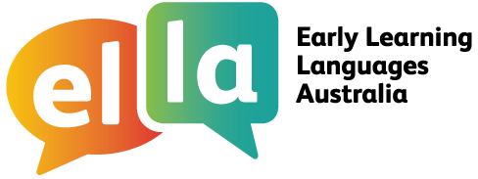

Things I can do in French
I have been learning French using The Polyglots apps.
French
Here are some of the things I can do in the language:
App 1: The Polyglots in the Playroom
I can sing a song in French
I can say some simple greetings in French
I can introduce myself in French
I can name some colours in French
I understand some simple instructions in French
I can express some likes and dislikes in French
I can count to 10 in French
I can say how old I am in French
I can say happy birthday in French
I can name some fruits in French
I can say I'm hungry/thirsty in French
I can say thank you in French
I can make simple requests in French
I can name some body parts in French
I can say some parts of the face in French
I can say something hurts in French
I can use some adjectives in French (eg big/small)
I can respond to some simple instructions in French using
action words
I can give some simple instructions in French using action words
I can use some adverbs in French (eg quickly/slowly)
I can name some shapes in French
I can recognise the meaning of some words written in French
I can say goodbye in French

App 7: The Polyglots in the Town

App 6: The Polyglots at the Park

App 5: The Polyglots at the Circus

App 4: The Polyglots at the Zoo

App 3: The Polyglots at the Birthday Party

App 2: The Polyglots at the Beach

Doing sometimes Beginning to do Regularly doing with assistance independently confidently

