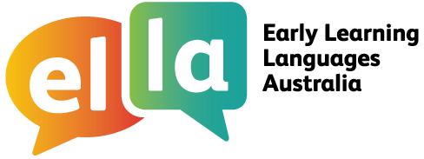

Things I can do in Chinese
Chinese
I have been learning Chinese using The Polyglots apps.

Here are some of the things I can do in the language:
Doing sometimes Beginning to do Regularly doing with assistance independently confidently

App 1: The Polyglots in the Playroom
I can sing a song in Chinese
I can say some simple greetings in Chinese I can introduce myself in Chinese

App 2: The Polyglots at the Beach

I can name some colours in Chinese
I understand some simple instructions in Chinese I can express some likes and dislikes in Chinese

App 3: The Polyglots at the Birthday Party

I can count to 10 in Chinese
I can say how old I am in Chinese
I can say happy birthday in Chinese

App 4: The Polyglots at the Zoo

I can name some fruits in Chinese
I can say I'm hungry/thirsty in Chinese I can say thank you in Chinese
I can make simple requests in Chinese

App 5: The Polyglots at the Circus

I can name some body parts in Chinese
I can say some parts of the face in Chinese I can say something hurts in Chinese
I can use some adjectives in Chinese (eg big/small)

App 6: The Polyglots at the Park
I can respond to some simple instructions in Chinese using action words
I can name some shapes in Chinese
I can recognise the meaning of some words written in Chinese I can say goodbye in Chinese
App 7: The Polyglots in the Town
I can give some simple instructions in Chinese using action words
I can use some adverbs in Chinese (eg quickly/slowly)

