
App 6: The Polyglots at the Park
Ready, set, go!
Learning intentions: We are learning about the verbs ‘running,’ ‘walking’ and ‘jumping’ using ________ (language).
Success criteria: I can follow instructions for the verbs ‘running,’ ‘walking’ and ‘jumping in ________ (language).
Resources: App 6, App 6 guide, ‘Ready, set, go! game’ printable, counters, dice, relay equipment: cones, batons and a finish line, historical information about athletics, Olympics and Paralympics
English; Visual Arts
Students illustrate their learnings from the ‘Ready, set, go!’ experience. They can draw Polyglots characters running a race, and write, copy or trace the target language words for running, jumping and walking. Encourage students to present their work to an audience once they have finished.
Australian Curriculum links (Foundation): ACELY1651, ACELY1647 and ACAVAM108
Assessment opportunities: The apps have been developed with subject matter experts. They are aligned to and support the learning outcomes of the Australian Curriculum: Languages for F–2.
You can find specific links to the Australian Curriculum for your language on the ELLA website, in the Educator Zone App Toolkit.
English; History
Athletics contests have a very long history, which you could introduce. Generate a discussion about the competitive athletics activities based on running, walking, jumping and throwing. Explore the different competitions and various participants’ achievements at Olympic Games and Paralympic Games. Students could illustrate their learnings. You might also explore the history of athletics with the students.
Australian Curriculum links (Foundation): ACELY1646 and ACHASSK013
Health and Physical Education
Extend this learning experience into a sport session with a relay on the school oval. Organise your students into teams and explain how relays work – that each student must follow the one before them to complete a section of the course. You could incorporate other movements into the relay and nominate students for particular actions such as walking, jumping or dancing. Incorporate the target language into your explanation of the movements.
Australian Curriculum links (Foundation): ACPMP008
English
Print and create enough copies of the ‘Ready, set, go! game’ printable for students to play in small groups. Encourage students to use the target language when rolling dice and when they land on the action space. Emphasise the importance of sharing and turn-taking.
Australian Curriculum links (Foundation): ACELY1784
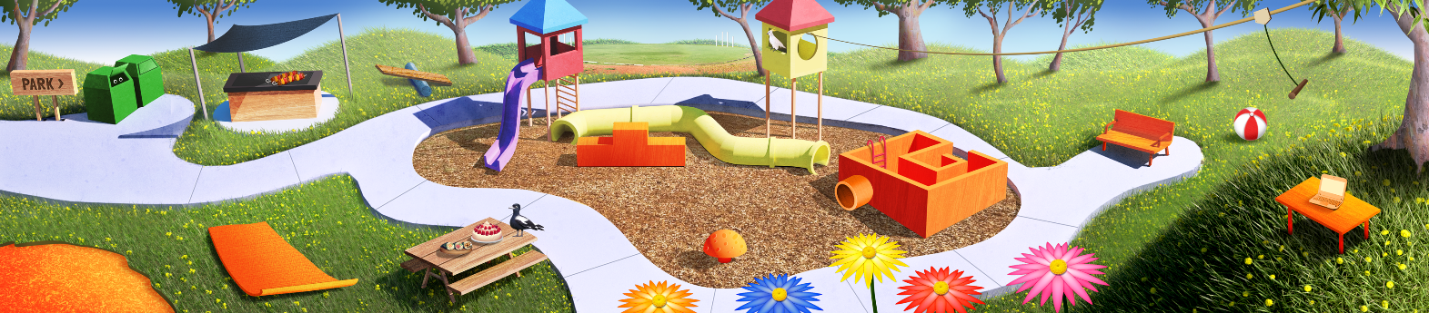

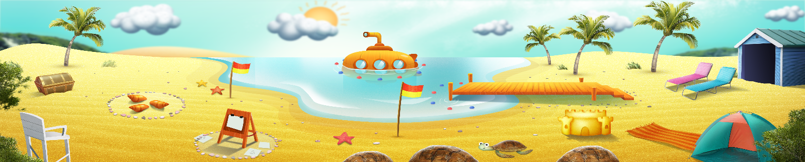




ELLA is funded by the Australian Government Department of Education, Skills and Employment and is managed by Education Services Australia. © 2021 Commonwealth of Australia, unless otherwise indicated. This material, other than Commonwealth trade marks in The Polyglots characters and The Polyglots logo, may be used in accordance with the Creative Commons BY-NC 4.0 licence unless otherwise indicated.

