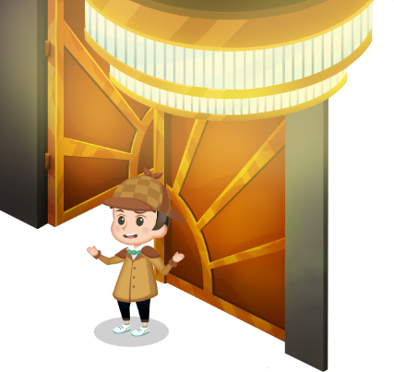
App 11: The Polyglots at the Concert
Polyglot detective
Learning intentions: We are learning to ask ‘Where is <person>?’ and respond with ‘At the <location>’, using _____________ (language).
Success criteria: I can describe where a person is located using _____________ (language).
Resources: App 11, App 11 guide, A3 paper, drawing materials, various construction materials.
Mathematics
The Polyglot detective experience contains four scenes; beach, park, party and circus. As a whole class, discuss which items can be found in which scenes and why. For example, could the octopus be located in the park? Why/why not? Construct a Venn diagram with two, three or four scenes to compare which items could be found where. Discuss reasons.
Australian Curriculum links (Year 2): ACMSP050

Physical Education
As a whole class, create an adaptation of Polyglot detective to play outside as a whole-class game. Students can take it in turns to play the role of the detective and the role of the hidden character. Encourage the students to use the target language for the phrase ‘Where is <person>?’ when searching for the hidden student.
Australian Curriculum links (Year 2): ACPMP027

English; Visual Arts
There are four possible scenes within this experience: beach, park, party and circus. Encourage students to choose a scene to illustrate with the heading of ‘Where is <person>?’ written/copied/traced using the target language. At the bottom of the illustration, students can write/copy/trace the sentence ‘At the <location>’ to demonstrate their understanding.
Australian Curriculum links (Year 2):
ACELY1671 and ACAVAM108

Assessment opportunities: The apps have been developed with subject matter experts. They are aligned
to and support the learning outcomes of the Australian Curriculum: Languages for F–2.
You can find specific links to the Australian Curriculum for your language on the ELLA website, in the
Educator Zone App Toolkit.

English; Visual Arts; Design and Technology
The Polyglot detective experience occurs inside a theatre. As a whole class, look at images of different types of theatres from around the world. Discuss and explore the features of theatres, including stage, curtains, lighting, backgrounds, props, audience and seating. Next, students may like to illustrate their own theatre and then, time permitting, they can plan, design and create their own 3D theatre using construction materials.
Australian Curriculum links (Year 2):
ACELY1666, ACAVAM108 and ACTDEP006

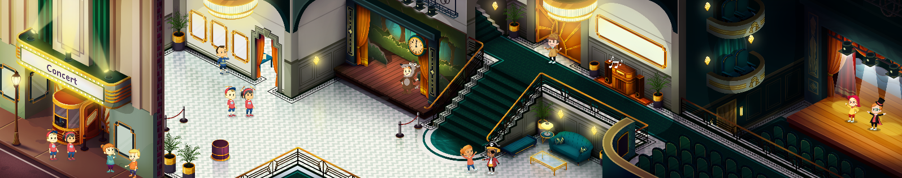


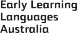

ELLA is funded by the Australian Government Department of Education, Skills and Employment and is managed by Education Services Australia. © 2021 Commonwealth of Australia, unless otherwise indicated. This material, other than Commonwealth trade marks in The Polyglots characters and The Polyglots logo, may be used in accordance with the Creative Commons BY-NC 4.0 licence unless otherwise indicated.

