App 8: The Polyglots go to School
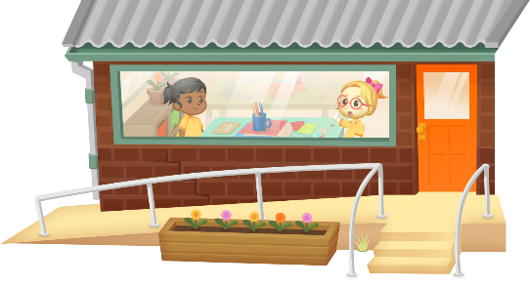
Label maker
Learning intentions: We are learning to label classroom items in ___________________ (language).
Success criteria: I can write labels for some classroom items using ______________ (language).
Resources: App 8, App 8 guide, paper, writing and drawing materials, scissors.
English
Students do a role-play activity, working in pairs to practise the question-and-answer phrases used in the ‘Label maker’ learning experience. Explain to your students that they will need to listen carefully so that they can identify the correct items and respond accurately to the requests of their role-play partner.
Australian Curriculum links (Year 1): ACELY1788
English
Using the content from the App 8 guide, create a set of cards that students in pairs can use to play games of Memory. Create half of the cards using images of the classroom items and the other half using the matching names of those items. After students find each matching pair, they practise the target language.
Australian Curriculum links (Year 1): ACELA1448

English; Humanities and Social Sciences
Compare a typical school day with that of students’ parents or grandparents. Find the main differences by asking such things as: What subjects did they study? Did they learn another language? What did their classrooms look like? What classroom objects did they use? This could either be a simple class discussion or an investigative project where students discuss school experiences with family members.
Australian Curriculum links (Year 1): ACELY1656
and ACHASSK030
Assessment opportunities: The apps have been developed with subject matter experts. They are aligned
to and support the learning outcomes of the Australian Curriculum: Languages for F–2.
Specific links to the Australian Curriculum for your language can be found on the ELLA website, in the
Educator Zone App Toolkit.
English
Use the App 8 guide’s label names as a reference for students to create labels for their own classroom items. Display the labels around your classroom and use them as a tool to help students request items using the target language. Cards can also be created for use during group-time activities.
Australian Curriculum links (Year 1): ACELY1661

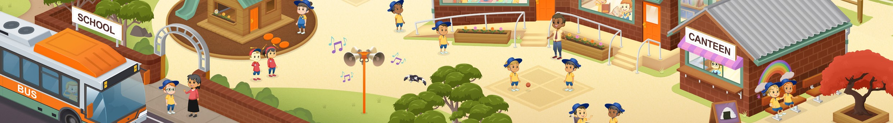

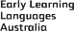

ELLA is funded by the Australian Government Department of Education, Skills and Employment and is managed by Education Services Australia. © 2020 Commonwealth of Australia, unless otherwise indicated. This material, other than Commonwealth trade marks in The Polyglots characters and The Polyglots logo, may be used in accordance with the Creative Commons BY-NC 4.0 licence unless otherwise indicated.

