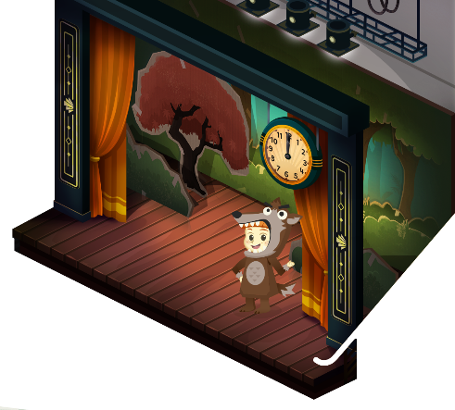
App 11: The Polyglots at the Concert
Mr Wolf
Learning intentions: We are learning how to tell the time in ___________________ (language).
Success criteria: I can tell the time in ___________________ (language).
Resources: App 11, App 11 guide, toy analogue clocks, paper plates, scissors, glue, split pins/paper brads, cardboard, colour pencils, various costumes.
Mathematics; Visual Arts
Provide students with the resources needed (listed above) to make a paper plate clock with hands that move. Students may like to include the cultural colours and/or patterns on the background of their clocks, as seen on the stage curtain within the Polyglot detective experience. Students can practise reading and telling the time using the target language.
Australian Curriculum links (Year 2): ACMMG039 and ACAVAM108

English; Drama
The polyglot character playing the role of the Mr Wolf character is dressed in a costume. Discuss and explore the purpose of costumes in dramatic play. How do costumes help to convey particular ideas?
Australian Curriculum links (Year 2):
ACELY1666 and ACADRM027

Physical Education
Play a whole-class game of Mr Wolf. Encourage the students to use the target language when counting the steps and asking the time. Students can take it in turns to be the wolf.
Australian Curriculum links (Year 2): ACPMP027
Mathematics
The Mr Wolf experience includes the language for reading the time on an analogue clock. Provide students with toy analogue clocks so that they can practise, in pairs, moving the hands to make the time and reading the time using the target language.
Australian Curriculum links (Year 2): ACMMG039

Assessment opportunities: The apps have been developed with subject matter experts. They are aligned
to and support the learning outcomes of the Australian Curriculum: Languages for F–2.
You will find specific links to the Australian Curriculum for your language on the ELLA website, in the
Educator Zone App Toolkit.
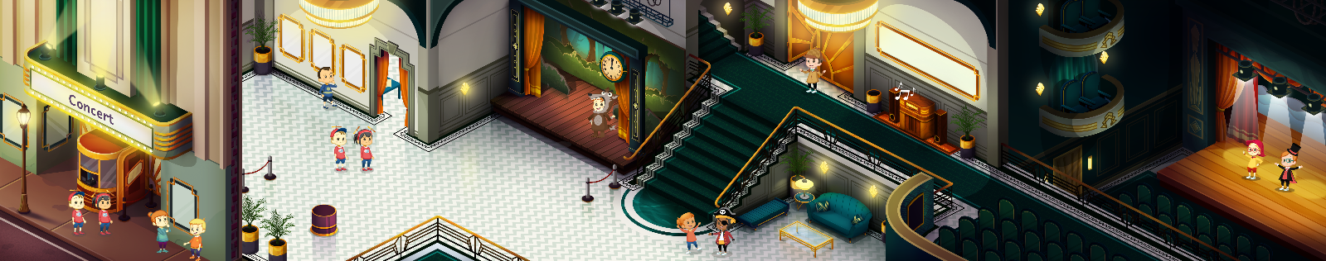


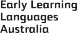

ELLA is funded by the Australian Government Department of Education, Skills and Employment and is managed by Education Services Australia. © 2021 Commonwealth of Australia, unless otherwise indicated. This material, other than Commonwealth trade marks in The Polyglots characters and The Polyglots logo, may be used in accordance with the Creative Commons BY-NC 4.0 licence unless otherwise indicated.

