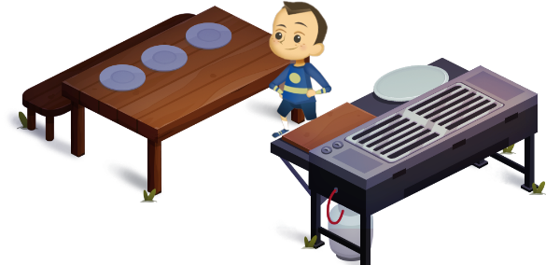
App 9: The Polyglots Go Camping
Camping cook-up
Learning intentions: We are learning how to say the names of some food items and how to say who the food belongs to, in_____________ (language
Success criteria: I can say the names of some food items in _____________ (language).
Resources: App 9, App 9 guide, A3 paper, art materials, pretend food items, kitchen-play equipment, cultural books.
English
Students illustrate scenes from ‘Camping cook-up’. They fold an A3 piece of paper in half twice, to create four sections. In each box, students write a phrase in the target language and draw the associated picture. For example:
Box 1 – ‘I’m hungry!’
Box 2 – ‘Whose is this?’
Box 3 – ‘It’s mine!’
Box 4 – ‘Delicious!’ / ‘Yum!’/ ‘Thank you!’
Refer to the App 9 guide for language support.
Australian Curriculum links (Year 1): ACELY1661
Drama
Students replicate ‘Camping cook-up’ in their classroom. Provide equipment such as pretend food items and a toy oven where the students can ‘cook’ food for their classmates. Encourage students to practise the scripted phrases such as ‘Whose is this?’ and ‘Grandma’s corn’, etc. Students take it in turns to play the different roles.
Australian Curriculum links (Year 1): ACADRM028

English; Science
The ‘Camping cook-up’ experience contains a cultural food item. Conduct a whole-class discussion and investigation to learn what other food items are culturally significant in the countries where your target language is spoken. Perhaps these foods are enjoyed as part of a cultural celebration. Use various resources to obtain information: books, maps and the Internet, and perhaps some class members themselves.
Australian Curriculum links (Year 1): ACELY1656 and ACSIS025
Assessment opportunities: The apps have been developed with subject matter experts. They are aligned
to and support the learning outcomes of the Australian Curriculum: Languages for F–2.
Specific links to the Australian Curriculum for your language can be found on the ELLA website, in the
Educator Zone App Toolkit.
English; Mathematics
Students conduct short surveys with their classmates, in pairs. The questioner asks a classmate which of the five food items from the Camp cook-up learning experience is their favourite. The classmate who responds is to use the target language.
Students record their findings in a bar graph.
Australian Curriculum links (Year 1): ACELY1788 and ACMSP263

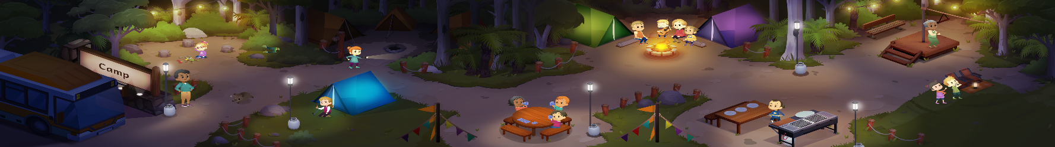


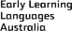

ELLA is funded by the Australian Government Department of Education, Skills and Employment and is managed by Education Services Australia. © 2020 Commonwealth of Australia, unless otherwise indicated. This material, other than Commonwealth trade marks in The Polyglots characters and The Polyglots logo, may be used in accordance with the Creative Commons BY-NC 4.0 licence unless otherwise indicated.

