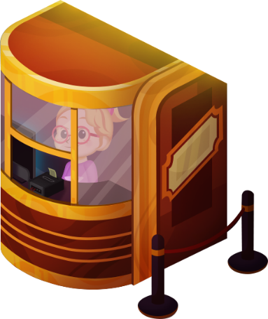
App 11: The Polyglots at the Concert
Ticket booth
Learning intentions: We are learning how to book a ticket using our knowledge of days and times in ___________________ (language).
Success criteria: I can book a ticket for a particular day and time in ___________________ (language).
Resources: App 11, App 11 guide, craft materials (sand trays, plasticine and match sticks), writing materials (crayons, textas and paints).
Mathematics
The Ticket booth experience contains the language for the days of the week. Provide students with a scrambled list of the days written in the target language and working in pairs, encourage students to practise their knowledge of the days to cut them out and paste them into their books in the correct order.
Australian Curriculum links (Year 2): ACMMG041

English; Visual Arts
Students can create their own collection of tickets, ready to use as part of a role-play activity. Encourage students to use the target language when writing/copying/tracing the details for the performance type, day of the week and the time. Encourage students to create multiple tickets with different details.
Australian Curriculum links (Year 2):
ACELY1671 and ACAVAM108

English; Drama
Set up a Ticket booth area in your classroom. Students can take it in turns to role-play the customer and the theatre employee to book tickets for a performance, using the target language. Students may like to use their own performance posters and tickets.
Australian Curriculum links (Year 2):
ACELY1666 and ACADRM027

English
Provide students with a range of hands-on craft materials such as sand trays, plasticine or match sticks to ‘make’ or ‘craft’ the different days of the week to practise their knowledge of the days using the target language. Students may like to practise writing the days using a range of writing materials such as crayons, textas or paints.
Australian Curriculum links (Year 2): ACELY1671

Assessment opportunities: The apps have been developed with subject matter experts. They are aligned to and support the learning outcomes of the Australian Curriculum: Languages for F–2.
You can find specific links to the Australian Curriculum for your language on the ELLA website, in the
Educator Zone App Toolkit.

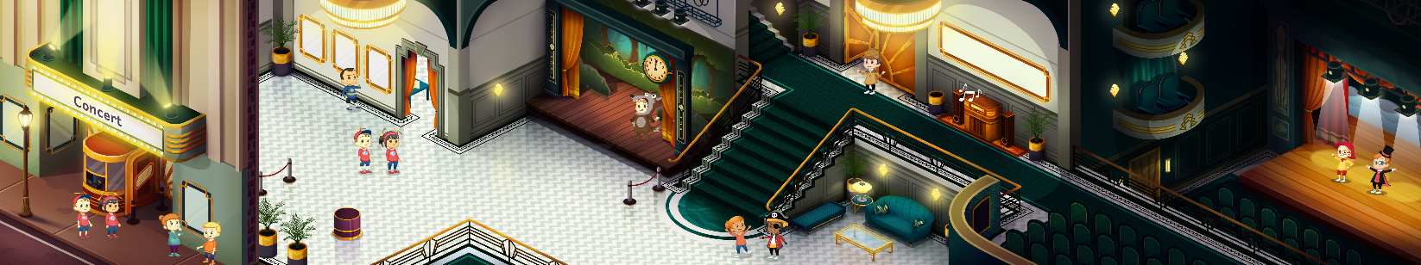


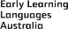

ELLA is funded by the Australian Government Department of Education, Skills and Employment and is managed by Education Services Australia. © 2021 Commonwealth of Australia, unless otherwise indicated. This material, other than Commonwealth trade marks in The Polyglots characters and The Polyglots logo, may be used in accordance with the Creative Commons BY-NC 4.0 licence unless otherwise indicated.

