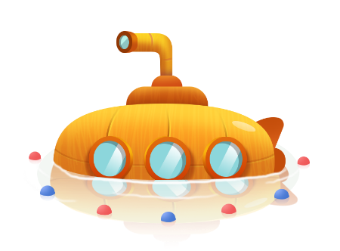
App 2: The Polyglots at the Beach
Submarine
Learning intentions: We are learning to identify and say the names of colours in ________ (language).
Success criteria: I can identify and say the names of colours in ________ (language).
Resources: App 2, App 2 guide, sea creature colour cards PDF, various craft materials such as coloured paper, cardboard boxes, straws, icy-pole sticks, glue
English
Students write a short reflective piece about their time ‘under the sea’. Use guiding questions such as ‘What did you see?’, ‘What did you hear?’ Students write and draw their responses. They can write/copy/trace the names of the colours to add to their descriptions. Encourage students to use the target language to describe the colours of the sea creatures.
Australian Curriculum links (Foundation): ACELY1651
English
Organise students into pairs or small groups to play a game of Memory using the sea creature colour cards. Encourage students to practise using the target language for the colours and for the names of the sea creatures as they find matching pairs.
Australian Curriculum links (Foundation): ACELY1646
Visual Arts; Design and Technologies
Tell students that they are going to design and then create their own submarine. Provide some initial ideas and demonstrate with the resources available (e.g. straws, cardboard boxes, icy-pole sticks). Students will need to plan their submarine by illustrating their ideas and explaining which materials they will use to construct it. For additional fun, students can test their submarines in a bucket of water!
Australian Curriculum links (Foundation): ACAVAM107, ACTDEP006 and ACTDEP007
Science
Generate a class discussion about life under the sea. What do students already know? What types of sea creatures are they aware of? Create a list on the board and then ask students to illustrate their understandings.
Australian Curriculum links (Foundation): ACSSU002
Assessment opportunities: The apps have been developed with subject matter experts. They are aligned to and support the learning outcomes of the Australian Curriculum: Languages for F–2.
You can find specific links to the Australian Curriculum for your language on the ELLA website, in the Educator Zone App Toolkit.

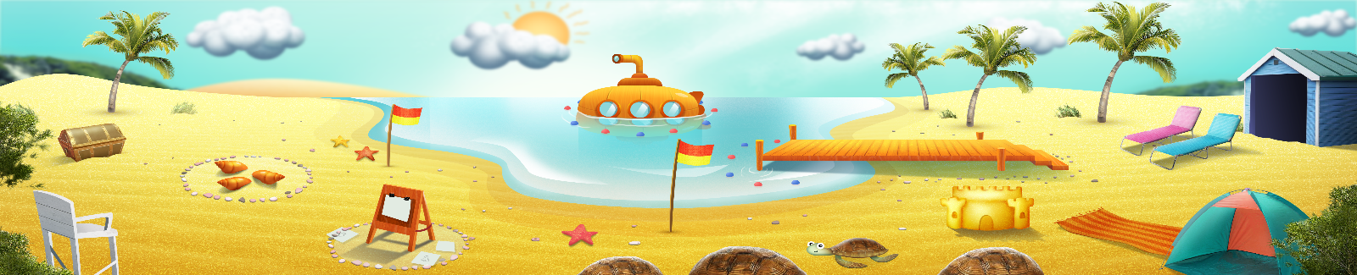


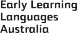
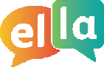
ELLA is funded by the Australian Government Department of Education, Skills and Employment and is managed by Education Services Australia. © 2021 Commonwealth of Australia, unless otherwise indicated. This material, other than Commonwealth trade marks in The Polyglots characters and The Polyglots logo, may be used in accordance with the Creative Commons BY-NC 4.0 licence unless otherwise indicated.

