
App 3: The Polyglots at the Birthday Party
Make a cake
Assessment opportunities: The apps have been developed with subject matter experts. They are aligned to and support the learning outcomes of the Australian Curriculum: Languages for F–2.
You can find specific links to the Australian Curriculum for your language on the ELLA website, in the Educator Zone App Toolkit.

Design and Technologies
Students can work together in small groups to make a basic cake (with an adult helper in each group). Choose a simple recipe and gather all necessary equipment and ingredients. Prior to beginning, explain the necessary safety and hygiene factors for preparing food (safe handling of knives and washing hands, etc). Students make the cake, taking it in turns to add and mix the ingredients and helping with cleaning at the end.
Australian Curriculum links (Foundation): ACTDEK003
Mathematics
Provide students with the same measuring equipment that they encountered in the app (measuring cups and jugs – more types can be included to extend learning as needed) and encourage them to compare the containers using either sand or water. Which container holds more sand/water or less sand/water? Which container is heavier? Begin using the language of formal measurements for each; for example, ‘one cup’.
Australian Curriculum links (Foundation): ACMMG006
Mathematics
Using the ‘Birthday dominoes’ printable, students work in pairs or small groups to play the traditional game of dominoes. Encourage students to count the candles on each cake (on each domino tile) using the target language. Then ask them to add the number of candles on the two matching tiles; for example, two candles plus two candles equals four candles.
Australian Curriculum links (Foundation): ACMNA004
English
Using ‘Make a cake’ ingredient cards, students play Memory in pairs or small groups. Print duplicate pages of the printable in your target language and cut out and create a set of cards for each pair/ group. (Hint: print two pages for a pair of students or four pages for a larger group.) Encourage students to say the name of each card’s ingredient in the target language as they turn over each card. The aim of the game is to find the matching pair of ingredient cards. The player with the most pairs wins.
Australian Curriculum links (Foundation): ACELY1646

Learning intentions: We are learning about different birthday celebrations and how to say ‘Happy birthday’ in ________ (language).
Success criteria: I can say ‘Happy birthday’ in ________ (language).
Resources: App 3, App 3 guide, ‘Birthday dominoes’ printable, ‘Make a cake’ printable ingredient cards, various items of measuring equipment, a basic cake recipe and all necessary ingredients and cooking equipment.


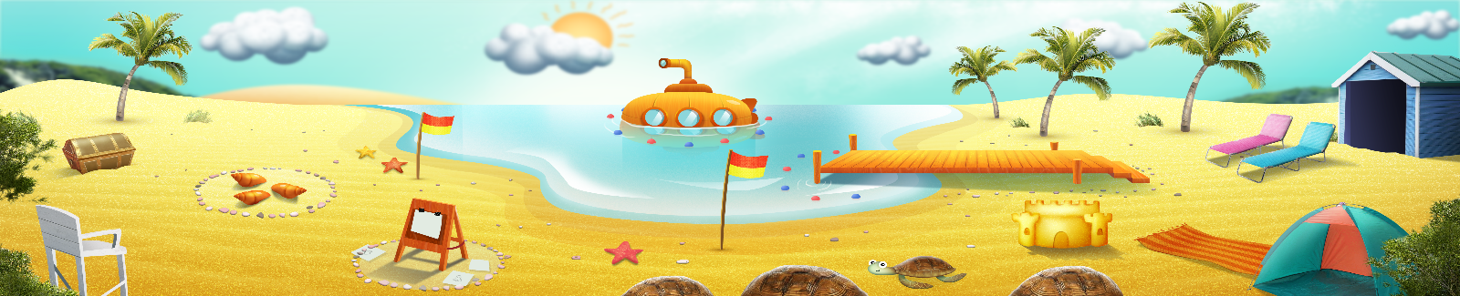


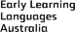

ELLA is funded by the Australian Government Department of Education, Skills and Employment and is managed by Education Services Australia. © 2021 Commonwealth of Australia, unless otherwise indicated. This material, other than Commonwealth trade marks in The Polyglots characters and The Polyglots logo, may be used in accordance with the Creative Commons BY-NC 4.0 licence unless otherwise indicated.

