App 8: The Polyglots go to School
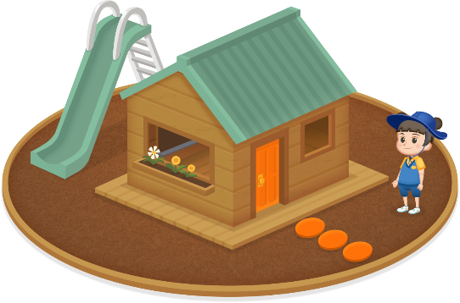
Pretend school
Learning intentions: We are learning to give and follow some classroom instructions in ___________________ (language).
Success criteria: I can give and follow some classroom instructions using _____________ (language).
Resources: App 8, App 8 guide, paper or card, scissors, safe materials for a student model building activity.
English
As a whole class, play a game of ‘Teacher says’ (modelling Tam). Use the verbs and instructions from the ‘Pretend school’ learning experience –for example, ‘Stand up’ or ‘Sit down quickly’. The App 8 guide contains a full list of them.
Australian Curriculum links (Year 1): ACELY1656

English
Using the content from the App 8 guide, create a set of cards that students in pairs can use to play games of Memory. Half of the cards would have an image from the ‘Pretend school’ learning experience. The other half could contain an associated instruction (for example, for an ear image, the instruction could be ‘Listen!’ in the target language).
Australian Curriculum links (Year 1): ACELA1448
English
Using the blackboard display from the cubby-house as a reference, students work in pairs to practise writing some of the words and instructions, using the target language. A range of materials can be used for ‘writing’: mini blackboards or whiteboards, sand trays for finger writing or other interesting materials.
Australian Curriculum links (Year 1): ACELY1663
Design and Technology
The ‘Pretend school’ learning experience occurs in a cubby-house. Ask your students to design and build a 3-D version of their own cubby-house, using a variety of safe building materials. Students could then use the ELLA character artwork to create 3-D Polyglots characters and replicate ‘Pretend school’ in their own cubby-houses.
Australian Curriculum links (Year 1): ACTDEP007

Assessment opportunities: The apps have been developed with subject matter experts. They are aligned
to and support the learning outcomes of the Australian Curriculum: Languages for F–2.
Specific links to the Australian Curriculum for your language can be found on the ELLA website, in the
Educator Zone App Toolkit.

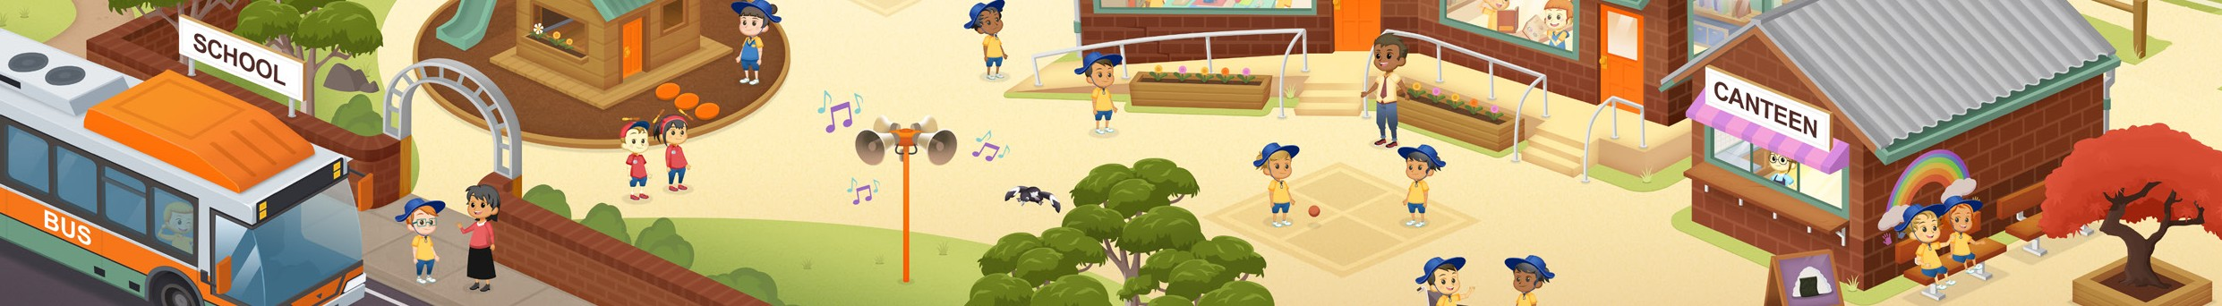

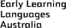
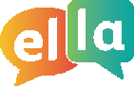
ELLA is funded by the Australian Government Department of Education, Skills and Employment and is managed by Education Services Australia. © 2020 Commonwealth of Australia, unless otherwise indicated. This material, other than Commonwealth trade marks in The Polyglots characters and The Polyglots logo, may be used in accordance with the Creative Commons BY-NC 4.0 licence unless otherwise indicated.

