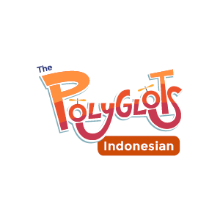
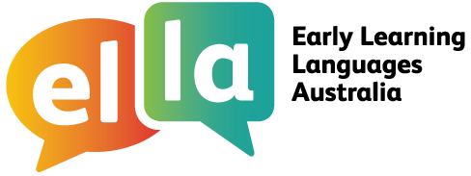
Things I can do in Indonesian
I have been learning Indonesian using The Polyglots apps.

Here are some of the things I can do in the language:
Doing sometimes Beginning to do Regularly doing with assistance independently confidently

App 1: The Polyglots in the Playroom
I can sing a song in Indonesian
I can say some simple greetings in Indonesian I can introduce myself in Indonesian

App 2: The Polyglots at the Beach

I can name some colours in Indonesian
I understand some simple instructions in Indonesian I can express some likes and dislikes in Indonesian

App 3: The Polyglots at the Birthday Party

I can count to 10 in Indonesian
I can say how old I am in Indonesian
I can say happy birthday in Indonesian

App 4: The Polyglots at the Zoo

I can name some fruits in Indonesian
I can say I'm hungry/thirsty in Indonesian I can say thank you in Indonesian
I can make simple requests in Indonesian

App 5: The Polyglots at the Circus

I can name some body parts in Indonesian
I can say some parts of the face in Indonesian I can say something hurts in Indonesian
I can use some adjectives in Indonesian (eg big/small)

App 6: The Polyglots at the Park
I can respond to some simple instructions in Indonesian using action words
I can name some shapes in Indonesian
I can recognise the meaning of some words written in Indonesian I can say goodbye in Indonesian
App 7: The Polyglots in the Town
I can give some simple instructions in Indonesian using action words
I can use some adverbs in Indonesian (eg quickly/slowly)

