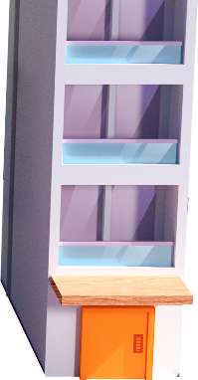
App 7: The Polyglots in the Town
Lift operator
Geography
As a whole class, use Google Earth to explore a city in the country where the target language is most often spoken. Look at the various features of the city, such as river(s) or lakes, signs, buildings and trees. How are these similar –and/or different – to our own towns/cities here in Australia? Students could demonstrate their new knowledge by illustrating aspects of the foreign city.
Australian Curriculum links (Foundation): ACHASSK015
Design and Technologies
In pairs or small groups, students use a range of different building materials to design and build a Polyglots town. They can model the town on the app or create a bigger town that includes features from other apps, such as the park in App 6. Explain the need to plan their design first and then decide on the building materials they want to use for the town. Where possible, encourage students to create signs for some buildings by writing, copying or tracing the names, using the target language.
Australian Curriculum links (Foundation): ACTDEP007 and ACTDEP009
Mathematics
Using building blocks of various shapes and sizes, children build their own multi-level building. Encourage students to name the shape faces (2D shapes) using the target language, and then start to explore the names of the 3D shapes together. Afterwards, students could illustrate their building.
Australian Curriculum links (Foundation): ACMMG009
Visual Arts
Each floor of the ‘Lift operator’ learning experience takes students to a different scene from a previous app. Using A3 paper, students choose to illustrate their favourite scene and, where possible, include some of the target language in their artwork. Encourage students to talk about why they chose this scene.
Australian Curriculum links (Foundation): ACAVAM108
Learning intentions: We are revising some of our new words in ________ (language) learnt from our experience with the ELLA apps.
Success criteria: I can demonstrate my knowledge of ________ (language) that I have learnt from the ELLA apps.
Resources: App 7, App 7 guide, A3 paper, coloured pencils, building blocks, craft materials: cardboard boxes, icy-pole sticks, matchsticks, coloured paper etc.
Assessment opportunities: The apps have been developed with subject matter experts. They are aligned to and support the learning outcomes of the Australian Curriculum: Languages for F–2.
You can find specific links to the Australian Curriculum for your language on the ELLA website, in the Educator Zone App Toolkit.
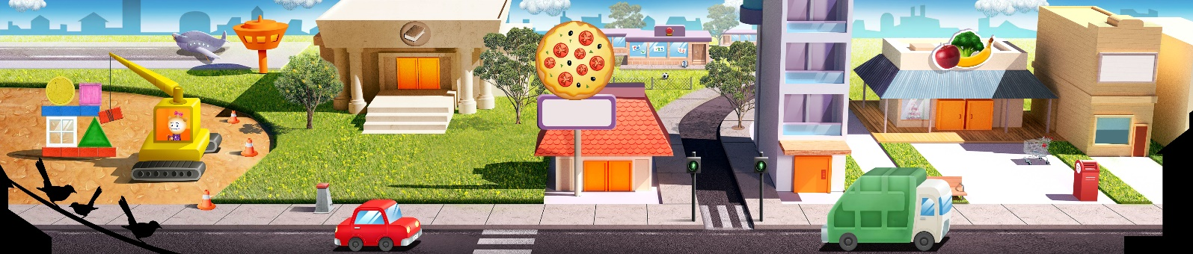

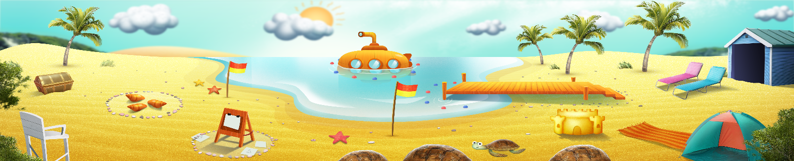


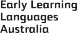
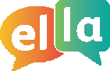
ELLA is funded by the Australian Government Department of Education, Skills and Employment and is managed by Education Services Australia. © 2021 Commonwealth of Australia, unless otherwise indicated. This material, other than Commonwealth trade marks in The Polyglots characters and The Polyglots logo, may be used in accordance with the Creative Commons BY-NC 4.0 licence unless otherwise indicated.

