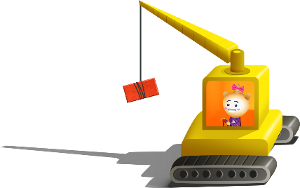
App 7: The Polyglots in the Town
Building site
Mathematics; Design and Technologies
In pairs, students design and make a ‘shapes house’ using a range of different building materials (such as small cardboard boxes, icy-pole sticks, matchsticks). Students draw their design, decide which materials to use and then make the model. Encourage students to use the target language for describing their chosen shapes.
Australian Curriculum links (Foundation): ACMMG009, ACTDEP007 and ACTDEP009
Mathematics
Organise a ‘shapes treasure hunt’ around the school. Take students on a walk around the playground and ask, ‘What shapes can you see?’ Students work in pairs and draw their responses on mini-whiteboards or notepaper. Then, when back inside, they illustrate their findings and draw shapes that they found. Encourage them to trace/copy/write the names of the shapes in the target language.
Australian Curriculum links (Foundation): ACMMG009
English; Visual Arts
Provide each student with an A3 or A4 piece of white paper and a set of coloured pencils. Then give drawing instructions (for example, ‘orange triangle’), one at a time, to the whole class, using the target language. The students listen carefully and draw what they hear anywhere on the paper, without showing anyone else. After five or six instructions, the students reveal their paper and check that they have drawn the correct shapes. Students in small groups then repeat the activity, taking it in turns to provide the instructions.
Australian Curriculum links (Foundation): ACELY1646 and ACAVAM108
English
Use the ‘Shape-matching game and poster’ printable to create a memory game for pairs or small groups. Print copies of the shape page and cut out and create a set of cards for each pair or group (use four pages for a pair of students, or six for a larger group). Encourage students to say the name of the shape using the target language as they turn over each card. (As an extension, include the doors and windows.) The aim: find the matching pairs of shapes. The player with the most pairs wins.
Australian Curriculum links (Foundation): ACELY1646
Learning intentions: We are learning how to name 2D shapes in ________ (language).
Success criteria: I can name 2D shapes in ________ (language).
Resources: App 7, App 7 guide, ‘Shape-matching game and poster’ printable, A4 and A3 white paper, various craft materials such as cardboard boxes, icy-pole sticks, matchsticks
Assessment opportunities: The apps have been developed with subject matter experts. They are aligned to and support the learning outcomes of the Australian Curriculum: Languages for F–2.
You can find specific links to the Australian Curriculum for your language on the ELLA website, in the Educator Zone App Toolkit.


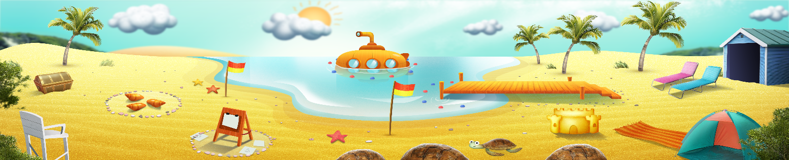




ELLA is funded by the Australian Government Department of Education, Skills and Employment and is managed by Education Services Australia. © 2021 Commonwealth of Australia, unless otherwise indicated. This material, other than Commonwealth trade marks in The Polyglots characters and The Polyglots logo, may be used in accordance with the Creative Commons BY-NC 4.0 licence unless otherwise indicated.

