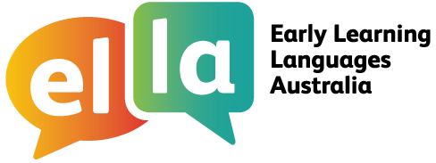

Spanish

Things I can do in Spanish
I have been learning Spanish using The Polyglots apps.

Here are some of the things I can do in the language:
Doing sometimes Beginning to do Regularly doing with assistance independently confidently

App 1: The Polyglots in the Playroom
I can sing a song in Spanish
I can say some simple greetings in Spanish I can introduce myself in Spanish

App 2: The Polyglots at the Beach

I can name some colours in Spanish
I understand some simple instructions in Spanish I can express some likes and dislikes in Spanish

App 3: The Polyglots at the Birthday Party

I can count to 10 in Spanish
I can say how old I am in Spanish
I can say happy birthday in Spanish

App 4: The Polyglots at the Zoo

I can name some fruits in Spanish
I can say I'm hungry/thirsty in Spanish I can say thank you in Spanish
I can make simple requests in Spanish

App 5: The Polyglots at the Circus

I can name some body parts in Spanish
I can say some parts of the face in Spanish I can say something hurts in Spanish
I can use some adjectives in Spanish (eg big/small)

App 6: The Polyglots at the Park
I can respond to some simple instructions in Spanish using action words
I can name some shapes in Spanish
I can recognise the meaning of some words written in Spanish I can say goodbye in Spanish
App 7: The Polyglots in the Town
I can give some simple instructions in Spanish using action words
I can use some adverbs in Spanish (eg quickly/slowly)

