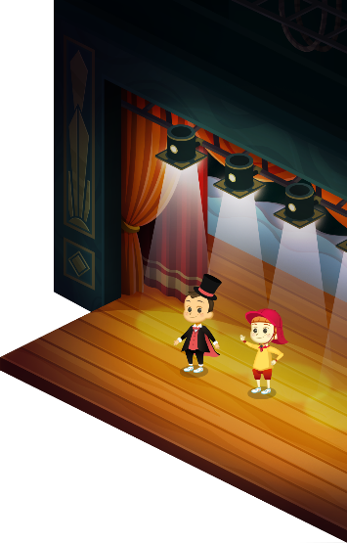
App 11: The Polyglots at the Concert
Perform a play
Learning intentions: We are learning how to create, write and perform a play using ___________________ (language).
Success criteria: I can create, write and perform a play in ___________________ (language).
Resources: App 11, App 11 guide, a collection of dress-ups/costumes, various craft materials.

English
As a whole class, brainstorm and list the language and content that the students have learnt from each of the ELLA apps. Then, using their knowledge of the language, encourage students to work together in pairs or small groups to write their own short role-play incorporating the target language. Students can start thinking about their costumes and props.
Australian Curriculum links (Year 2): ACELY1671
English; Visual Arts
Using a variety of craft materials, students can create props and backdrops for their plays. Encourage students to use the target language where possible, for example, in signage, advertising or labels.
Australian Curriculum links (Year 2):
ACELY1671 and ACAVAM108

English; Drama
Students can perform their plays for their classmates. Encourage students to use the target language as much as possible, including audience participation for revision language from earlier apps, such as ‘Fantastic!’, ‘Excellent!’ and ‘Wow!’.
Australian Curriculum links (Year 2):
ACELY1667 and ACADRM029
English; Drama
As a whole class, spend time watching short traditional plays performed in the country where the target language is spoken. Talk about the different aspects of performance (for example, costume, gestures, props, dialogue), and then explain to the students that they are going to create their own short role-play to perform.
Australian Curriculum links (Year 2):
ACELA1460 and ACADRR030

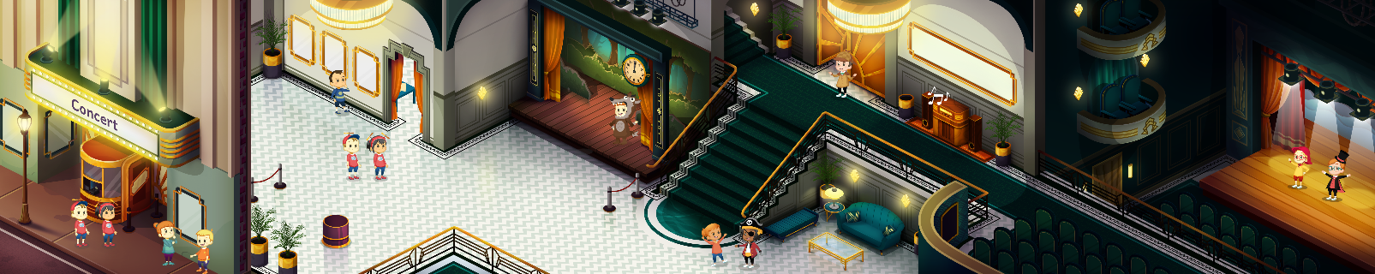
Assessment opportunities: The apps have been developed with subject matter experts. They are aligned
to and support the learning outcomes of the Australian Curriculum: Languages for F–2.
You can find specific links to the Australian Curriculum for your language on the ELLA website, in the
Educator Zone App Toolkit.


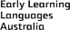

ELLA is funded by the Australian Government Department of Education, Skills and Employment and is managed by Education Services Australia. © 2021 Commonwealth of Australia, unless otherwise indicated. This material, other than Commonwealth trade marks in The Polyglots characters and The Polyglots logo, may be used in accordance with the Creative Commons BY-NC 4.0 licence unless otherwise indicated.

