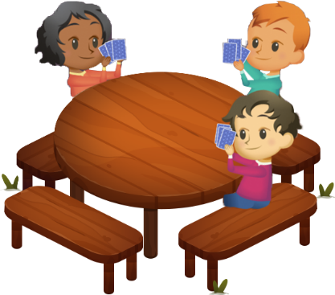
App 9: The Polyglots Go Camping
Families card game
Learning intentions: We are learning how to say the names of family members in ___________________ (language).
Success criteria: I can say the name of some family members using _____________ (language).
Resources: App 9, App 9 guide, Families PDF, A3 paper, art materials.
English
Organise a whole-class game of ‘Celebrity heads’. Students can take it in turns to sit, in twos or threes, facing the class. Place a picture of a family member from the Families PDF behind them, where they cannot see it. Working together, the students at the front ask various questions about the character’s appearance to work out who it is. They then use the target language for the character when they have identified who it is.
Australian Curriculum links (Year 1): ACELY1788
Humanities and Social Sciences
The Polyglots have different family structures. Ask the questions, ‘What is a family?’ and ‘What does it mean to be a family?’ With sensitivity and care, talk about the different types of families. Look at the importance of families in different cultures and discuss how some families live differently to others. Students may like to share some of their own family experiences with the class.
Australian Curriculum links (Year 1): ACHASSK028

English; Visual Arts
Students create their own family portrait. They paint members of their family and label each one, using the target language. They could also practise writing sentences to introduce their family, eg ‘This is my grandma,’ ‘This is my father’. Refer to the App 9 guide for a list of possible phrases.
Australian Curriculum links (Year 1): ACELY1661 and ACAVAM108

Assessment opportunities: The apps have been developed with subject matter experts. They are aligned
to and support the learning outcomes of the Australian Curriculum: Languages for F–2.
Specific links to the Australian Curriculum for your language can be found on the ELLA website, in the
Educator Zone App Toolkit.
English
Using the Families PDF, create a set of cards to replicate the game as seen within the ‘Families card game’ learning experience. Students can work in pairs or small groups to play the game. Encourage students to practise saying the names of the family members as they play.
Australian Curriculum links (Year 1): ACELY1788

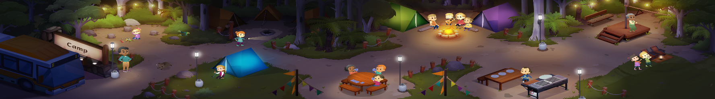


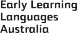

ELLA is funded by the Australian Government Department of Education, Skills and Employment and is managed by Education Services Australia. © 2020 Commonwealth of Australia, unless otherwise indicated. This material, other than Commonwealth trade marks in The Polyglots characters and The Polyglots logo, may be used in accordance with the Creative Commons BY-NC 4.0 licence unless otherwise indicated.

