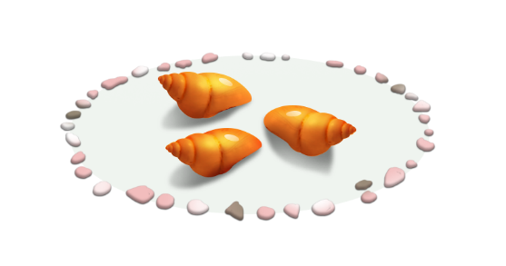
App 2: The Polyglots at the Beach
Shell memory
Learning intentions: We are learning the names of colours in ________ (language).
Success criteria: I can name some colours in ________ (language).
Resources: App 2, App 2 guide, colour board game, A3 paper, coloured paper squares (pre-cut), a container, coloured pencils/textas
English
Give students a piece of A3 paper containing a well-spaced list of large, wide names of colours in the ‘Shell memory’ experience – written in the target language. From a container of pre-cut small squares of coloured paper, students then choose the correct squares to match each colour word. They then glue the correct squares onto the letters/characters of this matching word.
Australian Curriculum links (Foundation): ACELY1651

Mathematics
Explain what the term ‘pattern’ means, and demonstrate this with colours, using the target language (e.g. in Italian, ‘rosso, blu, giallo, rosso, blu, giallo’). Encourage students to use coloured pencils, crayons or textas to create their own colour-pattern posters for a classroom display. Then, during sharing time, ask students to describe their patterns using the names of the colours in the target language.
Australian Curriculum links (Foundation): ACMNA005

Health and Physical Education
Play a whole-class game of ‘Rainbow’ on a basketball court. Using the target language, organise students into four colour groups. Each group then stands on a nominated side of the court and waits until they hear the teacher calling their colour. When their colour is called, they are to run/skip/jump to the appropriate side of the court. If the teacher calls ‘Rainbow’, all students are to run into the middle of the court.
Australian Curriculum links (Foundation): ACPPMP009 and ACPMP012
English
Print out and create the coloured crabs race game according to the instructions on the printable. Demonstrate for the class how to play the game using the target language. Then organise students into small groups for them to play the game together, encouraging them to use the target language as much as possible.
Australian Curriculum links (Foundation): ACELY1646
Assessment opportunities: The apps have been developed with subject matter experts. They are aligned to and support the learning outcomes of the Australian Curriculum: Languages for F–2.
You can find specific links to the Australian Curriculum for your language on the ELLA website, in the Educator Zone App Toolkit.

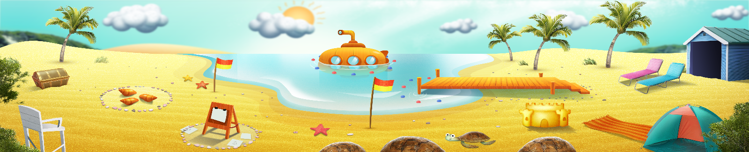


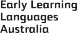

ELLA is funded by the Australian Government Department of Education, Skills and Employment and is managed by Education Services Australia. © 2021 Commonwealth of Australia, unless otherwise indicated. This material, other than Commonwealth trade marks in The Polyglots characters and The Polyglots logo, may be used in accordance with the Creative Commons BY-NC 4.0 licence unless otherwise indicated.

