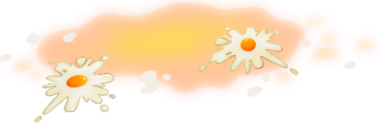
App 3: The Polyglots at the Birthday Party
Egg and spoon
Assessment opportunities: The apps have been developed with subject matter experts. They are aligned to and support the learning outcomes of the Australian Curriculum: Languages for F–2.
You can find specific links to the Australian Curriculum for your language on the ELLA website, in the Educator Zone App Toolkit.

Mathematics; Health and Physical Education
Set up a ‘numbers treasure hunt’. First, create variously sized number cards that contain a number word from one to ten in the target language. Hide these around the school playground, then organise students into pairs or small groups. Next, gather them at a starting location. Call out a number in the target language and send the student groupings on a hunt to find the ‘treasure’ – the corresponding number card.
Australian Curriculum links (Foundation): ACMNA002 and ACPMP009.
Mathematics
Give students a range of counting objects (such as blocks, counters, buttons, pegs) to use while practising counting in sequence from one to ten in the target language. The students could then demonstrate their counting knowledge by illustrating arrangements of objects that they choose.
Australian Curriculum links (Foundation): ACMNA001
Health and Physical Education
Organise students into groups to re-enact the game from the app using wooden spoons and tennis balls (or an actual egg and spoon toy set). Encourage students to practise counting aloud using the target language.
Australian Curriculum links (Foundation): ACPMP009
Visual Arts
Selecting from a range of craft materials such as crayons, paint, fabric pieces and sand, students design and create their own numbers poster using the target language.
Australian Curriculum links (Foundation): ACAVAM108
Learning intentions: We are learning how to count to ten in ________ (language).
Success criteria: I can count to ten and can recognise the numbers from 1 to 10 in _______ (language).
Resources: App 3, App 3 guide, wooden spoons, tennis balls, number chart printable, various craft materials such as crayons, paint, fabric pieces, A3 paper.
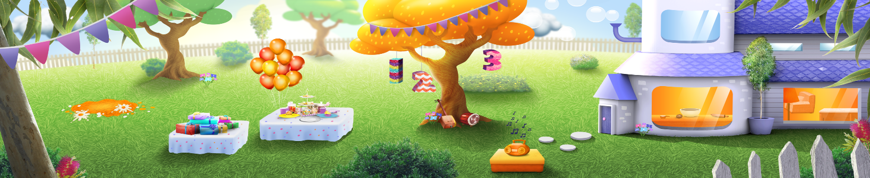

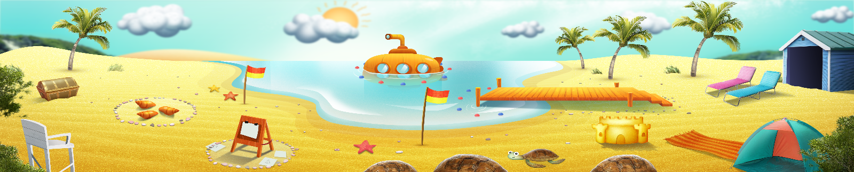


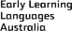
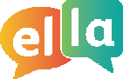
ELLA is funded by the Australian Government Department of Education, Skills and Employment and is managed by Education Services Australia. © 2021 Commonwealth of Australia, unless otherwise indicated. This material, other than Commonwealth trade marks in The Polyglots characters and The Polyglots logo, may be used in accordance with the Creative Commons BY-NC 4.0 licence unless otherwise indicated.

