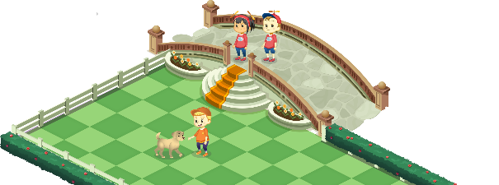
App 10: The Polyglots at the Pet Park
Puppy trainer
Learning intentions: We are learning to give and follow some instructions for training pets in ___________________ (language).
Success criteria: I can give and follow some instructions for training pets using _____________ (language).
Resources: App 10, App 10 guide, A3 paper, scissors, safe materials (e.g. matchsticks) for a design and construction activity
English
Using the content from the App 10 guide, create a set of cards that students in pairs can use to play games of ‘Memory’. Half of the cards would have an image from ‘Puppy trainer’. The other half could contain an associated instruction (for example, include an illustration of the puppy walking for the instruction ‘Walk’ in the target language).
Australian Curriculum links (Year 2): ACELY1671
English
Generate a whole-class discussion about training animals. Discuss domestic animals versus wild animals. What are the differences? Many animals have been used in TV and movies; what are some of these famous animals? Students may like to conduct their own research into famous animals and share their findings with the class.
Australian Curriculum links (Year 2): ACELY1789

Design and Technology; English
Using A3 paper, students can create their own puppy training course complete with various obstacles. They may wish to create 3D obstacles, for example, using matchsticks to create fences as part of their design. In pairs, students guide each other through the obstacle courses using the commands in target language. Toys dogs or a drawing of a dog on a card could be used to navigate the course.
Australian Curriculum links (Year 2): ACTDEP007 and ACELY1666
Assessment opportunities: The apps have been developed with subject matter experts. They are aligned
to and support the learning outcomes of the Australian Curriculum: Languages for F–2.
You can find specific links to the Australian Curriculum for your language on the ELLA website, in the
Educator Zone App Toolkit.

English; Health and Physical Education
The Puppy trainer activity contains the language for a set of commands: stop, go, walk, jump, run and sit. As a whole class, play a game of ‘Teacher says’ using the verbs and instructions in the target language. The App 10 guide contains a full list.
Australian Curriculum links (Year 2): ACELY1666 and ACPMP027

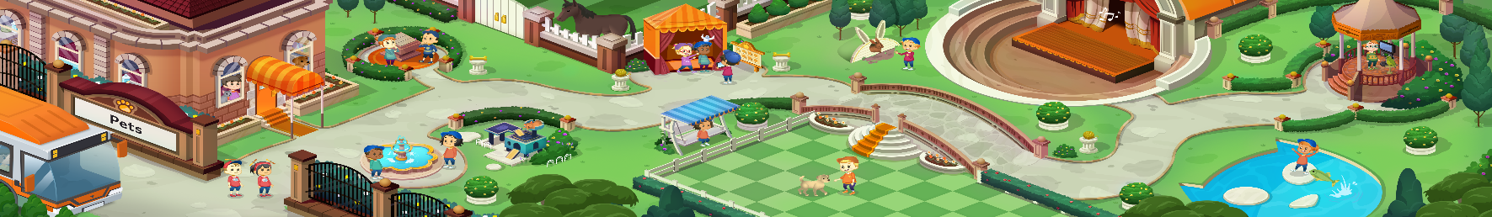


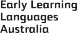

ELLA is funded by the Australian Government Department of Education, Skills and Employment and is managed by Education Services Australia. © 2021 Commonwealth of Australia, unless otherwise indicated. This material, other than Commonwealth trade marks in The Polyglots characters and The Polyglots logo, may be used in accordance with the Creative Commons BY-NC 4.0 licence unless otherwise indicated.

