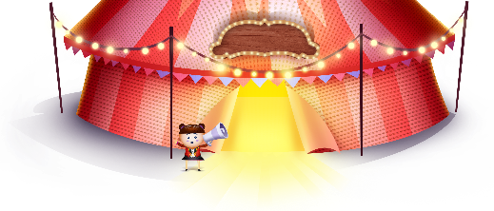
App 5: The Polyglots at the Circus
Clown trainer
Assessment opportunities: The apps have been developed with subject matter experts. They are aligned to and support the learning outcomes of the Australian Curriculum: Languages for F–2.
You can find specific links to the Australian Curriculum for your language on the ELLA website, in the Educator Zone App Toolkit.
English
Play a game of Simon Says using the names of the body parts as learnt from the song ‘Head, arms, legs and feet’. For example: ‘Simon says, put your hand on your (name of body part using the target language).’ Extend language through inclusion of the adjectives big and small, and revise the colours using the target language.
Australian Curriculum links (Foundation): ACELY1646
English; Visual Arts
Students hear and learn the names of various body parts in the target language. They can demonstrate their knowledge by drawing a picture of themselves and labelling as many parts of their body using the target language as possible. The ‘Parts of the body poster’ printable is a useful resource for this activity.
Australian Curriculum links (Foundation): ACELY1651 and ACAVAM108
Health and Physical Education
The ‘Clown trainer’ learning experience includes various acrobatic moves. Create an obstacle and movement course with or without equipment for students to complete. The course could include some of the movements from the app.
Australian Curriculum links (Foundation): ACPMP008
Learning intentions: We are learning how to say the names of various body parts in ________ (language).
Success criteria: I can say the names of body parts in ________ (language).
Resources: App 5, App 5 guide, the ‘Parts of the body poster’ printable, various art and craft materials such as cardboard boxes, fabric, straws and pipe cleaners
Visual Arts
Selecting from a range of craft materials (such as cardboard boxes, fabric, straws and pipe cleaners), students design and create their own circus diorama. They may like to include some of the scenes from the app, draw on their prior knowledge from a circus experience or both
Australian Curriculum links (Foundation): ACAVAM108
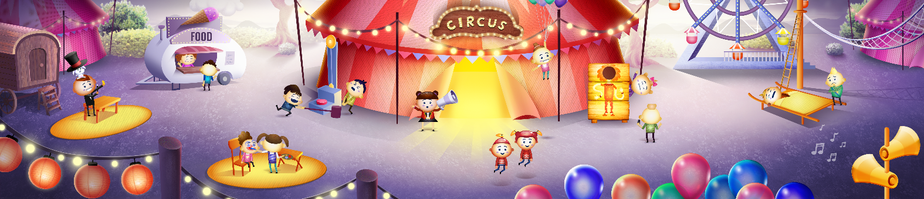

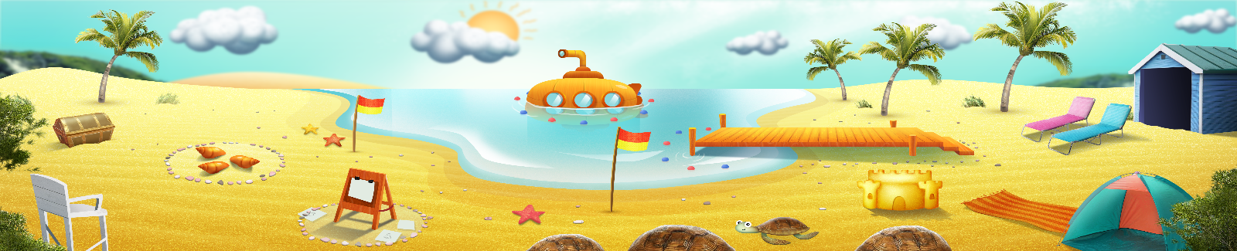


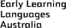

ELLA is funded by the Australian Government Department of Education, Skills and Employment and is managed by Education Services Australia. © 2021 Commonwealth of Australia, unless otherwise indicated. This material, other than Commonwealth trade marks in The Polyglots characters and The Polyglots logo, may be used in accordance with the Creative Commons BY-NC 4.0 licence unless otherwise indicated.

