App 8: The Polyglots go to School
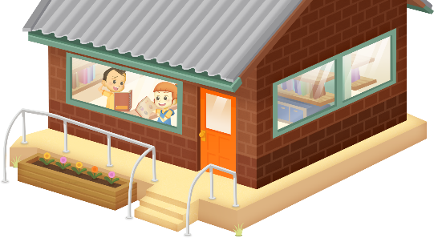
About me
Learning intentions: We are learning to give a self-introduction in ___________________ (language).
Success criteria: I can introduce and share some details about
myself using ______________ (language).
Resources: App 8, printouts of the ELLA character artwork from the Educator Zone App 8 Toolkit, artwork materials.
English
Students prepare a short oral presentation about themselves. They use the target language to present phrases such as:
- Hi. My name is ______________
- I am six years old.
- I like music.
Australian Curriculum links (Year 1): ACELY1657
English
Using printouts of the ELLA character artwork from the App 8 Toolkit, students replicate the information shared by Min’s and Kai’s scrapbooks. They work in pairs to listen to the likes and dislikes of each character and then draw these items on the posters, showing which are liked and which disliked. Students could also practise writing some of the modelled sentences next to the items, using the target language.
Australian Curriculum links (Year 1): ACELY1655
English and Mathematics
Conduct a whole-class survey. Ask your students to choose their favourite item from a selection of items in the app. Encourage them to respond using modelled phrases in the target language. Students then work together to display this information in bar graphs.
Australian Curriculum links (Year 1): ACELY1788, ACMSP262 and ACMSP263
English and Visual Arts
Students create their own About Me books or posters. They use a variety of materials to convey the kinds of details about themselves that are referenced within the app. Students practise writing some of the modelled sentences using the target language, and include these in their artwork.
Australian Curriculum links (Year 1): ACELY1661 and ACAVAM107
Assessment opportunities: The apps have been developed with subject matter experts. They are aligned
to and support the learning outcomes of the Australian Curriculum: Languages for F–2.
Specific links to the Australian Curriculum for your language can be found on the ELLA website, in the
Educator Zone App Toolkit.

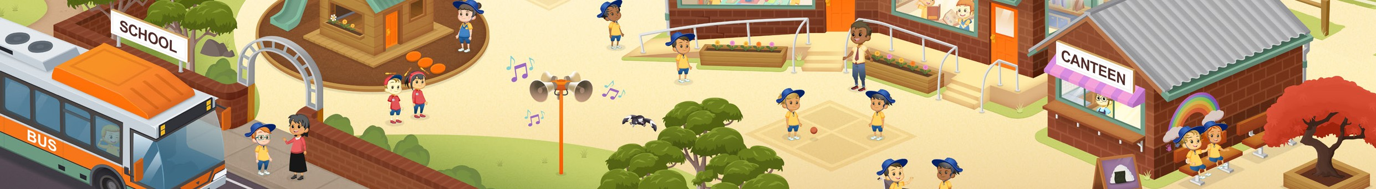

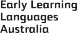
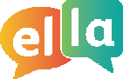
ELLA is funded by the Australian Government Department of Education, Skills and Employment and is managed by Education Services Australia. © 2020 Commonwealth of Australia, unless otherwise indicated. This material, other than Commonwealth trade marks in The Polyglots characters and The Polyglots logo, may be used in accordance with the Creative Commons BY-NC 4.0 licence unless otherwise indicated.

