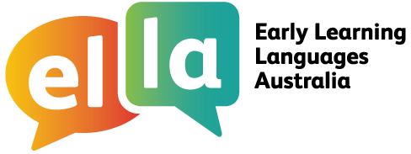
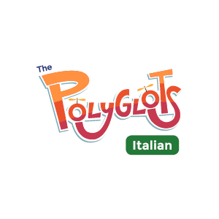

Things I can do in Italian
I have been learning Italian using The Polyglots apps.

Here are some of the things I can do in the language:
Doing sometimes Beginning to do Regularly doing with assistance independently confidently

App 1: The Polyglots in the Playroom
I can sing a song in Italian
I can say some simple greetings in Italian
I can introduce myself in Italian

App 2: The Polyglots at the Beach

I can name some colours in Italian
I understand some simple instructions in Italian
I can express some likes and dislikes in Italian

App 3: The Polyglots at the Birthday Party

I can count to 10 in Italian
I can say how old I am in Italian
I can say happy birthday in Italian

App 4: The Polyglots at the Zoo

I can name some fruits in Italian
I can say I'm hungry/thirsty in Italian
I can say thank you in Italian
I can make simple requests in Italian

App 5: The Polyglots at the Circus

I can name some body parts in Italian
I can say some parts of the face in Italian
I can say something hurts in Italian
I can use some adjectives in Italian (eg big/small)

App 6: The Polyglots at the Park
I can respond to some simple instructions in Italian using action words
I can name some shapes in Italian
I can recognise the meaning of some words written in Italian
I can say goodbye in Italian
App 7: The Polyglots in the Town
I can give some simple instructions in Italian using action words
I can use some adverbs in Italian (eg quickly/slowly)

