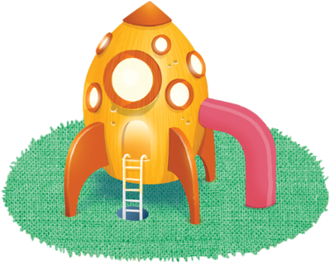
App 1: The Polyglots in the Playroom
Rocket ship
Learning intentions: We are learning to interact in _______ (language).
Success criteria: I can say hello and introduce myself in _______ (language).
Resources: App 1, App 1 guide, Polyglots puppet template PDF, A3 paper, various craft materials such as coloured paper, safety scissors, straws, icy-pole sticks, glue; six to eight cones, four hula-hoops.
Mathematics
Students design and paste onto A3 paper their own two-dimensional rockets, using different coloured paper that they cut into various shapes. Encourage them to use familiar shapes such as squares, rectangles and triangles. Students could then illustrate a space scene around their rocket similar to the one seen from the dashboard of the rocket in the learning experience.
Australian Curriculum links (Foundation): ACMMG009

Health and Physical Education
Prepare for a ‘Space tag’ game on a basketball court, with cones in a circle (the ‘Black Hole’) and hula-hoops (‘space stations’) around the court. Appoint four students as ‘aliens’ (taggers) whose job is to catch all of the ‘astronauts’ (all other students). Each captured astronaut is taken to the Black Hole. They can be rescued from this area by another astronaut and can hide inside a space station, one at a time.
Australian Curriculum links (Foundation): ACPMP009
Visual Arts; Design and Technologies
Explain to students that they are going to use a variety of materials to design and create their own rocket ships. Provide some ideas and demonstrate with the available resources (e.g. straws, icy-pole sticks). Students will need to plan their rocket ship by illustrating their ideas and explaining which materials they will use to construct their design.
Australian Curriculum links (Foundation): ACAVAM107, ACTDEP006 and ACTDEP007

English
This learning experience looks at the language of greetings spoken by the characters as they fly past. Using the Polyglots puppet template PDF, encourage students to play with the puppets to practise the greetings ‘Hello’ and ‘My name is …’ in the target language.
Australian Curriculum links (Foundation): ACELY1646
Assessment opportunities: The apps have been developed with subject matter experts. They are aligned to and support the learning outcomes of the Australian Curriculum: Languages for F–2.
You can find specific links to the Australian Curriculum for your language on the ELLA website, in the Educator Zone App Toolkit.

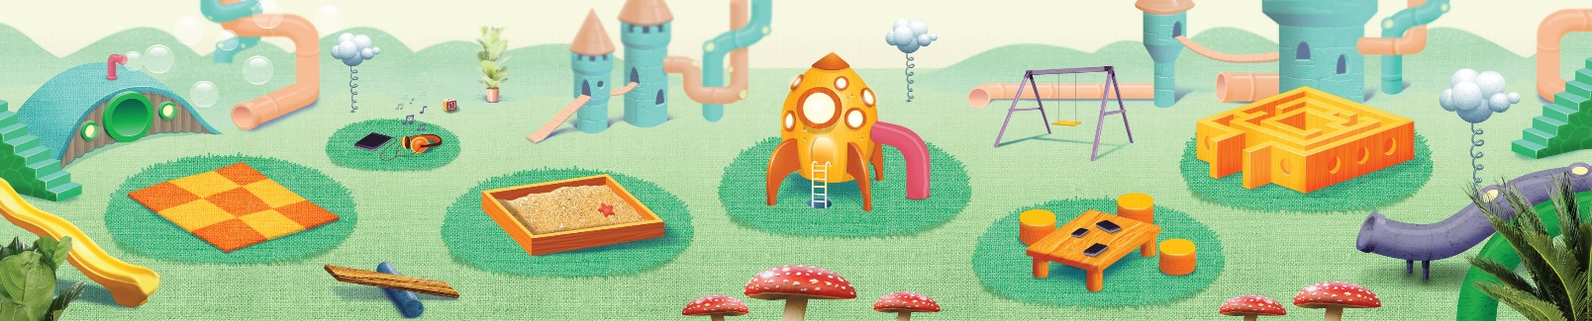


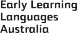

ELLA is funded by the Australian Government Department of Education, Skills and Employment and is managed by Education Services Australia. © 2021 Commonwealth of Australia, unless otherwise indicated. This material, other than Commonwealth trade marks in The Polyglots characters and The Polyglots logo, may be used in accordance with the Creative Commons BY-NC 4.0 licence unless otherwise indicated.

