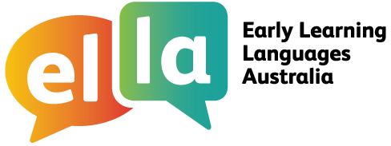

Things I can do
ICT and intercultural understanding for Hindi

I have been learning Hindi using The Polyglots apps on a tablet device.
Here are some of the things I can do when using ICT (information and communication technology):

Doing sometimes with assistance

Beginning to do
independently

Regularly doing confidently

I can use icons to find information (eg access a particular part of the app to find a specific activity, word or phrase)

I can use ICT in a variety of ways on a tablet

I can recognise and use my own avatar (digital work)

I can follow class rules about using digital information

I can follow class rules when sharing personal information with known audiences

I can safely use a tablet to complete relevant simple specified tasks, and I seek help when encountering a problem

Note: These statements are adapted from the ICT Capability learning continuum of the Australian Curriculum, for Foundation (the first year of school).

While learning some Hindi language I have also been learning about the cultures of the people who speak Hindi. This has helped me understand more about languages and cultures, including my own language and culture. Here are some of the things I have been doing:

Doing sometimes with assistance

Beginning to do
independently

Regularly doing confidently

I share ideas about ‘self’ and ‘belonging’ with peers

I enjoy identifying, exploring and comparing culturally diverse
activities and objects

I have participated in discussions about the cultural diversity in my local context

I recognise that people use different languages to communicate

I can identify and describe memorable intercultural experiences

I am able to identify examples of the acceptance and inclusion of others in given situations

I notice cultural similarities and differences between myself
and other people I know


Note: These statements are adapted from the Intercultural Understanding Capability learning continuum of the Australian Curriculum for Foundation
(the first year of school).

