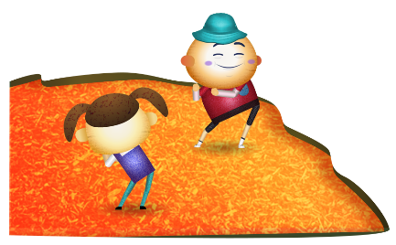
App 6: The Polyglots at the Park
Follow the leader
English
In small groups, students take it in turns to replicate the ‘Follow the leader’ learning experience by being the leader. Encourage students to use the target language for the various verbs and phrases including ‘That was fun!’ and ‘That was good!’ Find opportunities for including these phrases into other classroom activities.
Australian Curriculum links (Foundation): ACELY1784
Visual Arts
Students create their own artwork of the App 6 playspace. Encourage students to use a variety of materials including natural items such as twigs and leaves. Once finished, the students could share various features of their work with in pairs, small groups or with a friend.
Australian Curriculum links (Foundation): ACAVAM107 and ACAVAM108
Health and Physical Education
Give students a range of sports equipment (bean bags, hula hoops) and ask them to design a short exercise routine that includes the actions from the ‘Actions’ song. Your school’s playground equipment could be useful, too. Encourage students to use the target language for ‘run’, ‘jump’, ‘walk’ and ‘sing’ from page 8 of the App 6 guide. You could refer to an enlarged version of the ‘Action dice and poster’ printable.
Australian Curriculum links (Foundation): ACPMP009
Learning intentions: We are learning how to use positive phrases in ________ (language).
Success criteria: I can use positive phrases in ________ (language).
Resources: App 6, App 6 guide, ‘Action dice and poster’ printable, App 6 song, ‘Positive phrases poster’ printable, a range of sports equipment items such as hula hoops and throwable bean bags, various natural craft materials such as twigs and leaves
English; Health and Physical Education
Referring to the ‘Positive phrases poster’ printable, generate a class discussion about the phrases. Talk about why it is important to encourage others, and yourself encourage students to share a time when they have given compliments or support to others. How did it make them feel? Students may like to illustrate their experiences.
Australian Curriculum links (Foundation): ACELY1646 and ACPPS004
Assessment opportunities: The apps have been developed with subject matter experts. They are aligned to and support the learning outcomes of the Australian Curriculum: Languages for F–2.
You can find specific links to the Australian Curriculum for your language on the ELLA website, in the Educator Zone App Toolkit.
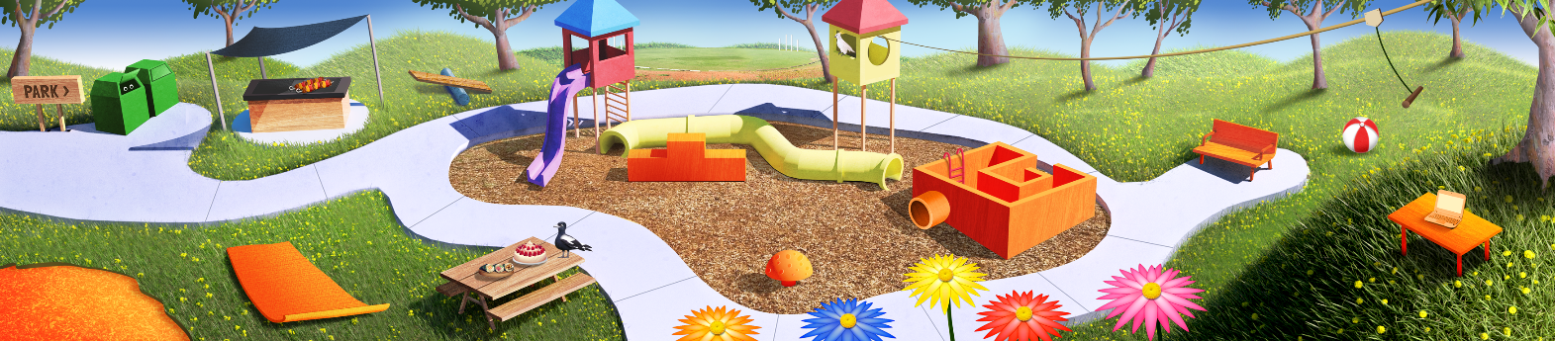

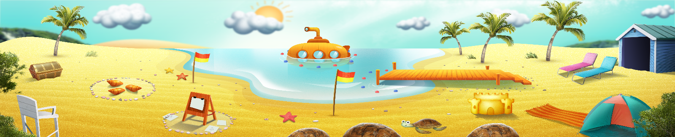


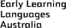

ELLA is funded by the Australian Government Department of Education, Skills and Employment and is managed by Education Services Australia. © 2021 Commonwealth of Australia, unless otherwise indicated. This material, other than Commonwealth trade marks in The Polyglots characters and The Polyglots logo, may be used in accordance with the Creative Commons BY-NC 4.0 licence unless otherwise indicated.

