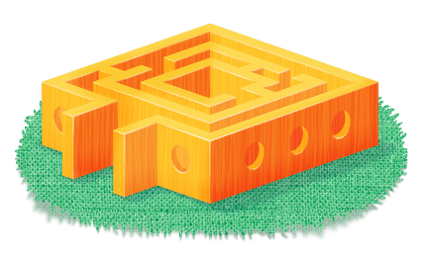
App 1: The Polyglots in the Playroom
Maze
Learning intentions: We are learning to interact in ________ (language).
Success criteria: I can say hello and introduce myself (or a Polyglots character) in ________ (language).
Resources: App 1, App 1 guide, building blocks, Polyglots character artwork PDF, building materials such as straws, icy-pole sticks, glue
Mathematics
In pairs, students use different-shaped building blocks to build a maze for the Polyglots. Print enough copies of the Polyglots character artwork PDF for each student to choose a character. Stick the characters on icy-pole sticks, and encourage students to move the Polyglots through their mazes, practising the language of greetings as they ‘meet’ other Polyglots.
Australian Curriculum links (Foundation): ACMMG010

English
Generate a whole-class discussion about the concept of a maze – what is a maze? Look at different types of mazes from around the world. What do students notice? Keep a list of common features for later discussion and use.
Australian Curriculum links (Foundation): ACELY1646
Visual Arts; Design and Technologies
Using a variety of resources, explain to students that they are going to design and create their own mazes. Provide some ideas and demonstrate with the available resources (such as straws and icy-pole sticks). Students will need to plan their maze by illustrating their ideas and explaining which materials they will use to construct it.
Australian Curriculum links (Foundation): ACAVAM107, ACTDEP006 and ACTDEP007

Health and Physical Education
Set up a ‘maze’ game 5 x 5 grid on a basketball court, using plastic markers or chalk circles. For yourself, record a pathway on paper. Explain to students that each step they take must land on a marker/circle. They line up at the starting spot, taking turns to guess which spot to step to next. If correct, they can keep going. If mistaken, they move to the end of the line and the next student tries. Students need to remember the correct markers to get through the maze.
Australian Curriculum links (Foundation): ACPMP009
Assessment opportunities: The apps have been developed with subject matter experts. They are aligned to and support the learning outcomes of the Australian Curriculum: Languages for F–2.
You can find specific links to the Australian Curriculum for your language on the ELLA website, in the Educator Zone App Toolkit.

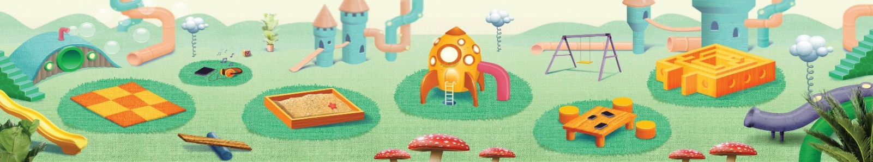


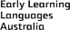
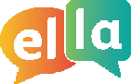
ELLA is funded by the Australian Government Department of Education, Skills and Employment and is managed by Education Services Australia. © 2021 Commonwealth of Australia, unless otherwise indicated. This material, other than Commonwealth trade marks in The Polyglots characters and The Polyglots logo, may be used in accordance with the Creative Commons BY-NC 4.0 licence unless otherwise indicated.

