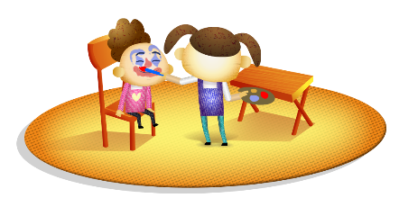
App 5: The Polyglots at the Circus
Face painter
Visual Arts
With your students, explore the works – portraits in particular – by a famous artist, perhaps Pablo Picasso. Provide students with materials such as paint, pastels, fabric and coloured paper, then encourage them to create their own ‘Picasso’ (or other artist) piece from these.
Australian Curriculum links (Foundation): ACAVAM108
English; History
For many cultures, face painting is a part of traditional celebrations and events. Explore the history of face painting around the world, including its origins and significance in Aboriginal and Torres Strait Islander cultures. For example, how is this painting associated with the passing of cultural knowledge from one generation to another?
Australian Curriculum links (Foundation): ACELY1646 and ACHASSK011
Assessment opportunities: The apps have been developed with subject matter experts. They are aligned to and support the learning outcomes of the Australian Curriculum: Languages for F–2.
You can find specific links to the Australian Curriculum for your language on the ELLA website, in the Educator Zone App Toolkit.
English; Visual Arts
Students draw pictures of different faces to demonstrate their understanding of the adjectives learnt from ‘Face painter’. They write, copy or trace the target language words for ‘big’, ‘small’, ‘long’ and ‘short’, and then draw heads with different features. For example; they could design a face with a big nose, big mouth, short hair and blue eyes or a head with a small nose, small mouth, long hair and brown eyes.
Australian Curriculum links (Foundation): ACELY1651 and ACAVAM108
Learning intentions: We are learning how to use adjectives to describe parts of the face using ________ (language).
Success criteria: I can describe parts of the face using adjectives in ________ (language).
Resources: App 5, App 5 guide, A3 paper, various art materials such as paint, pastels, fabric and coloured paper, flat garden stones (of roughly the same size).
Health
As an extension activity, students explore the concept of emotions. How do we know when someone is happy, sad, upset and so on? What does their face look like? Provide students with a collection of flat stones and encourage them to choose a stone and paint a face on it that reflects one of these emotions.
Australian Curriculum links (Foundation): ACPPS005
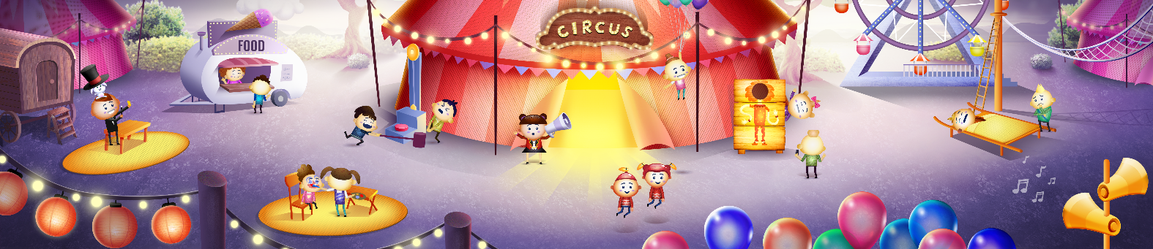

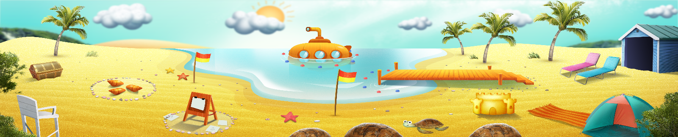


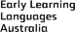

ELLA is funded by the Australian Government Department of Education, Skills and Employment and is managed by Education Services Australia. © 2021 Commonwealth of Australia, unless otherwise indicated. This material, other than Commonwealth trade marks in The Polyglots characters and The Polyglots logo, may be used in accordance with the Creative Commons BY-NC 4.0 licence unless otherwise indicated.

