
App 3: The Polyglots at the Birthday Party
Hide and seek
Assessment opportunities: The apps have been developed with subject matter experts. They are aligned to and support the learning outcomes of the Australian Curriculum: Languages for F–2.
You can find specific links to the Australian Curriculum for your language on the ELLA website, in the Educator Zone App Toolkit.

Visual Arts
Selecting from a range of art materials such as crayons and paint, students design their own imaginary house. What special features does it have? Encourage creativity with their ideas.
Australian Curriculum links (Foundation): ACAVAM108
Geography
App 3 contains cultural items often found in homes of people who speak the target language. Explore these and other cultural items, then any special features of homes in the place or places where the language is spoken. How are these similar –and/or different – to our own homes and familiar cultural objects? Students could demonstrate their knowledge by illustrating the special features of places that make them home to the people who live in them.
Australian Curriculum links (Foundation): ACHASSK015
Design and Technology
Encourage students (in pairs) to build a house using building blocks and/or craft materials such as cardboard boxes and icy-pole sticks. Students then take it in turns to re-enact the ‘Hide and seek’ experience. One ‘hides’ the pre-constructed Polyglot character resource (picture stuck on an icy-pole stick) inside the house. The seeker then counts to ten using the target language before beginning to search for the hidden Polyglot.
Australian Curriculum links (Foundation): ACTDEK003
Learning intentions: We are learning how to count to ten in ________ (language).
Success criteria: I can count to ten and can recognise the numbers from 1 to 10 in _______ (language).
Resources: App 3, App 3 guide, building blocks, craft materials (such as cardboard boxes, icy-pole sticks); Polyglots that you have already created by greatly reducing the size of characters from the character artwork printable and sticking them to icy-pole sticks; art materials (for example, paint, crayons).
Health and Physical Education
Organise students into groups to play games of hide and seek in the playground. Encourage the seekers to count using the target language.
Australian Curriculum links (Foundation): ACPMP009

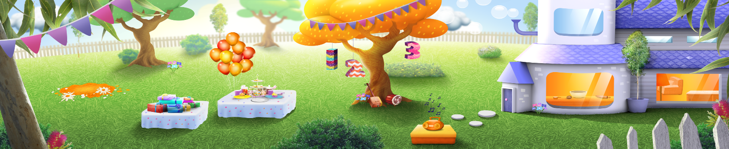

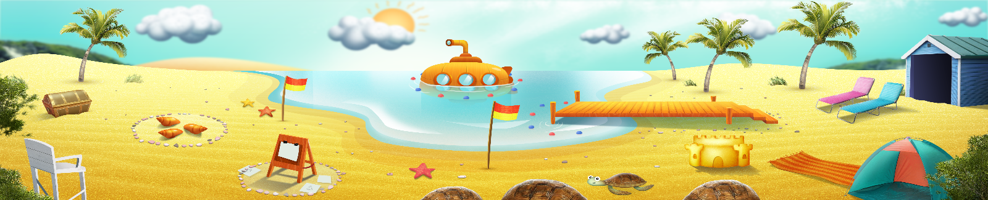


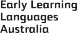

ELLA is funded by the Australian Government Department of Education, Skills and Employment and is managed by Education Services Australia. © 2021 Commonwealth of Australia, unless otherwise indicated. This material, other than Commonwealth trade marks in The Polyglots characters and The Polyglots logo, may be used in accordance with the Creative Commons BY-NC 4.0 licence unless otherwise indicated.

