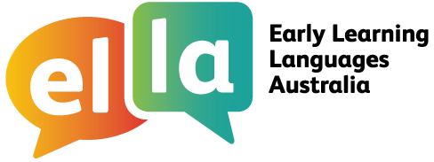

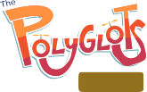Things I can do
Spanish
ICT and intercultural understanding for Spanish

I have been learning Spanish using The Polyglots apps on a tablet device.
Here are some of the things I can do when using ICT (information and communication technology):

Doing sometimes Beginning to do Regularly doing with assistance independently confidently
I can use icons to find information (eg access a particular part of the app to find a specific activity, word or phrase)

I can use ICT in a variety of ways on a tablet
I can recognise and use my own avatar (digital work)
I can follow class rules about using digital information
I can follow class rules when sharing personal information with known audiences

I can safely use a tablet to complete relevant simple specified tasks, and I seek help when encountering a problem

Note: These statements are adapted from the ICT Capability learning continuum of the Australian Curriculum, for Foundation (the first year of school).

While learning some Spanish language I have also been learning about the cultures of the people who speak Spanish. This has helped me understand more about languages and cultures, including my own language and culture.
Here are some of the things I have been doing:

I share ideas about ‘self’ and ‘belonging’ with peers
Doing sometimes Beginning to do Regularly doing with assistance independently confidently
I enjoy identifying, exploring and comparing culturally diverse activities and objects

I have participated in discussions about the cultural diversity in my local context

I recognise that people use different languages to communicate
I can identify and describe memorable intercultural experiences
I am able to identify examples of the acceptance and inclusion of others in given situations

I notice cultural similarities and differences between myself and other people I know


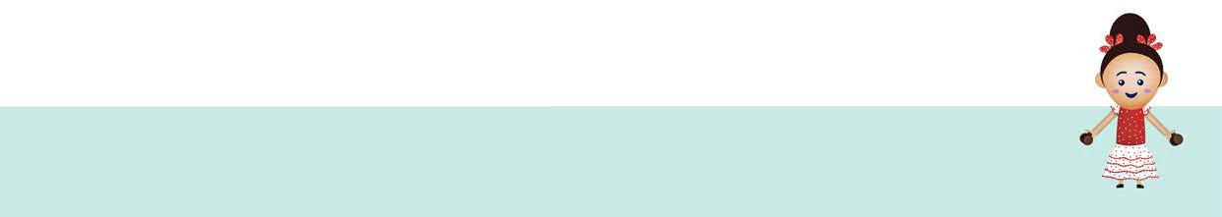Note: These statements are adapted from the Intercultural Understanding Capability learning continuum of the Australian Curriculum for Foundation (the first year of school).
ELLA is funded by the Australian Government Department of Education and is managed by Education Services Australia. © 2019 Commonwealth of Australia, unless otherwise indicated. This material, other than Commonwealth trade marks in The Polyglots characters and The Polyglots logo, may be used in accordance with the Creative Commons BY-NC 4.0 licence, unless otherwise indicated.

Education Services Australia Limited ABN 18 007 342 421
Level 5 440 Collins Street, Melbourne Victoria 3000 Australia
www.esa.edu.au E ella@esa.edu.au
T +61 3 9207 9600 ELLA helpdesk 1800 468 303

