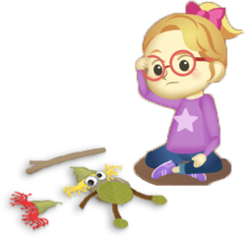
App 9: The Polyglots Go Camping
Bush collage
Learning intention: We are learning how to say the names of family members in ___________________ (language).
Success criteria: I can say the name of some family members using _____________ (language).
Resources: App 9, App 9 guide, Families PDF, paper, natural materials (leaves, stones, gumnuts, twigs, etc), glue, and plenty of counters.
English; Visual Arts
Students create a bush collage poster using some of the natural items gathered during the nature treasure hunt (see Mathematics). They make this collage, ‘Self-portrait with family members’, using the smaller items (leaves, stones, gumnuts, twigs, etc). Students label each family member using the target language. They also practise writing sentences to introduce their family, eg ‘My grandma’, ‘My father’.
Australian Curriculum links (Year 1): ACELY1661 and ACAVAM107
English
Create a set of cards that pairs of students will use to play games of Snap or Memory. Create half of the cards using the family-member images from the Families PDF and the other half using the matching names of those characters. After students find each matching pair, they practise the target language.
Australian Curriculum links (Year 1): ACELA1448
English
Using the Families PDF family-member images, create a bingo-style game board for each student. Use the same number of family faces for each board, but vary (and repeat a few) characters and their placement. Randomly call out family members’ names in turn, using the target language. Students with that family member on their board are to repeat the language and place a counter on that square. The winner is the student who first covers all the squares.
Australian Curriculum links (Year 1): ACELA1448

Assessment opportunities: The apps have been developed with subject matter experts. They are aligned
to and support the learning outcomes of the Australian Curriculum: Languages for F–2.
Specific links to the Australian Curriculum for your language can be found on the ELLA website, in the
Educator Zone App Toolkit.
Mathematics
As a whole class, spend time outside in the playground on a ‘nature treasure hunt’. Students collect various natural materials (leaves, stones, gumnuts, twigs, etc) of different sizes, shapes, textures and density. Encourage students to classify the objects they find according to these features. These objects can be placed on a separate table in the classroom for students to use while creating their own bush collage.
Australian Curriculum links (Year 1): ACMMG022

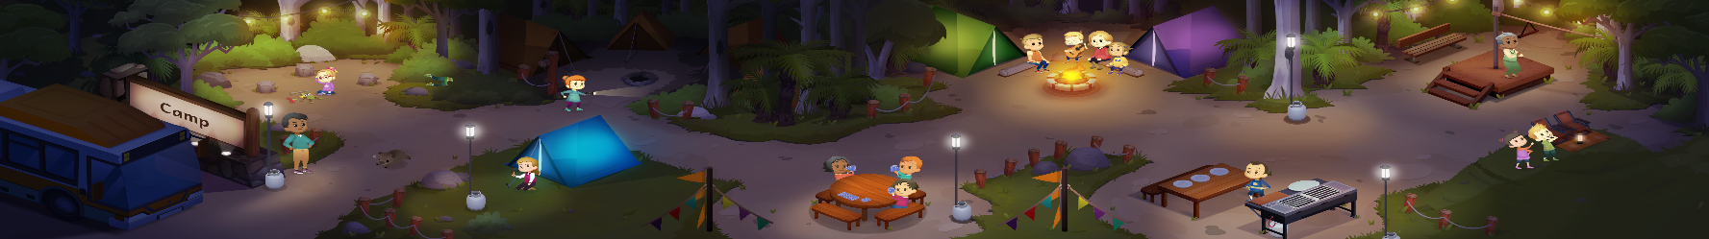

ELLA is funded by the Australian Government Department of Education, Skills and Employment and is managed by Education Services Australia. © 2020 Commonwealth of Australia, unless otherwise indicated. This material, other than Commonwealth trade marks in The Polyglots characters and The Polyglots logo, may be used in accordance



ELLA is funded by the Australian Government Department of Education, Skills and Employment and is managed by Education Services Australia. © 2020 Commonwealth of Australia, unless otherwise indicated. This material, other than Commonwealth trade marks in The Polyglots characters and The Polyglots logo, may be used in accordance with the Creative Commons BY-NC 4.0 licence unless otherwise indicated.

