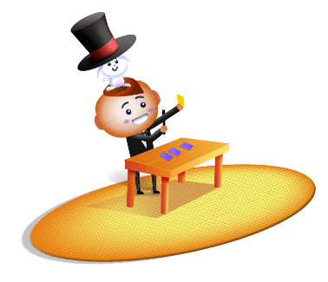
App 5: The Polyglots at the Circus
Memory cards
Learning intentions: We are learning how to label parts of the body in ________ (language).
Success criteria: I can label parts of the body in ________ (language).
Resources: App 5, App 5 guide, ‘Memory cards’ printable, ‘Parts of the body dice’ printable, a collection of magazines and/or newspapers, A3 paper, safe scissors, MP3 of the App 5 song, and art materials such as paint, crayons, fabric pieces and coloured paper
Assessment opportunities: The apps have been developed with subject matter experts. They are aligned to and support the learning outcomes of the Australian Curriculum: Languages for F–2.
You can find specific links to the Australian Curriculum for your language on the ELLA website, in the Educator Zone App Toolkit.
Visual Arts
Provide students with a large collection of magazines and/or newspapers. Explain that they are going to create a face collage using pictures of eyes, ears, noses and mouths that they need to find and cut out. Encourage students to practise saying the names of the face parts using the target language. Students may like to sing along to the ‘Heads, arms, legs and feet’ song while working.
Australian Curriculum links (Foundation): ACAVAM108
English
As in the’ Memory cards’ learning experience, students play games of Concentration using the ‘Memory cards’ printable. (Make sure you print out enough copies of these for students to play in pairs or in small groups.) Encourage students to practise saying the names of the body parts using the target language.
Australian Curriculum links (Foundation): ACELY1784
English
Print out as many ‘Memory cards’ printables as you will need to cut out the cards on them and then create individual Bingo boards that each have a different selection of body parts. Give a board to each student and, using the ‘Parts of the body dice’ printable, play a game of Bingo using the target language. Encourage students to practise saying the names of the body parts using the target language.
Australian Curriculum links (Foundation): ACELY1784
Visual Arts
Selecting from a range of craft materials such as crayons, paint and fabric pieces, students design and create their own circus scene, taking inspiration from the App 5 playspace. They may like to create a circus tent from coloured paper.
Australian Curriculum links (Foundation): ACAVAM108
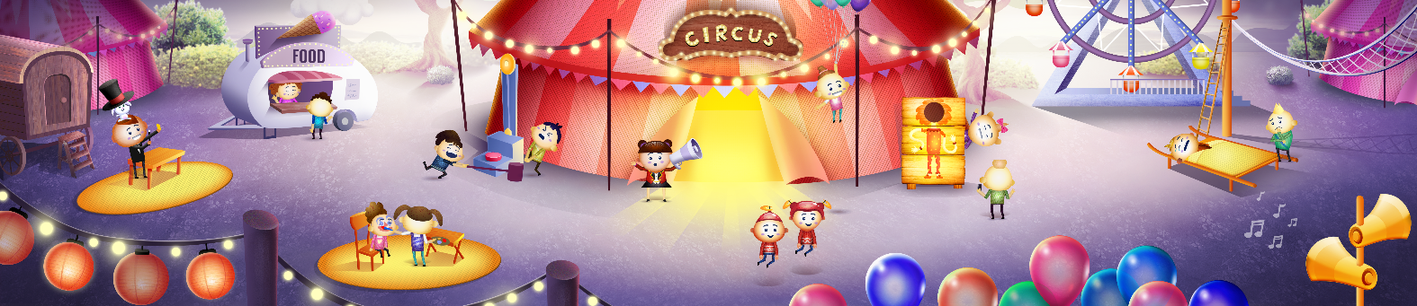

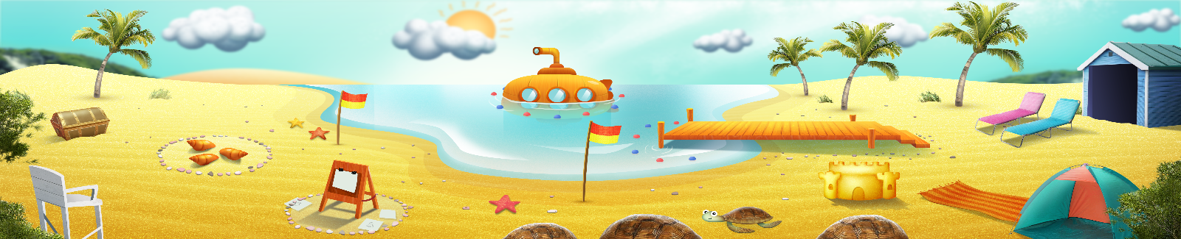


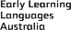

ELLA is funded by the Australian Government Department of Education, Skills and Employment and is managed by Education Services Australia. © 2021 Commonwealth of Australia, unless otherwise indicated. This material, other than Commonwealth trade marks in The Polyglots characters and The Polyglots logo, may be used in accordance with the Creative Commons BY-NC 4.0 licence unless otherwise indicated.

