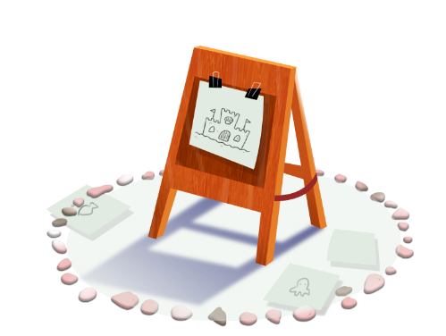
App 2: The Polyglots at the Beach
Colour and create
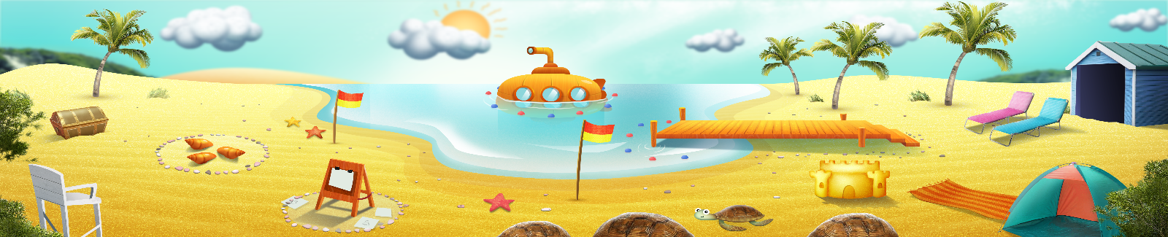
Assessment opportunities: The apps have been developed with subject matter experts. They are aligned to and support the learning outcomes of the Australian Curriculum: Languages for F–2.
You can find specific links to the Australian Curriculum for your language on the ELLA website, in the Educator Zone App Toolkit.

English
Students create their own 4-page mini-storybook about the beach playspace, using a folded piece of white A4 white paper. Help them write, copy or trace words as needed. Students can use some of the matching sea creature cards to help them write the text into their book; for example:
Cover (page 1): Look!
Page 2: Look! Blue crabs.
Page 3: Look! Red octopus.
Page 4: Look! Green and pink fish.
Australian Curriculum links (Foundation): ACELY1651 and ACELA1435

English
Generate a whole-class discussion about the beach. What are the features of our Australian beaches? Compare these with beaches in other countries. What are the similarities and differences?
Australian Curriculum links (Foundation): ACELY1646
Humanities and Social Sciences
Following the beach discussion (above), as a whole class look at various maps to identify which of the world’s countries would have a beach. Why or why wouldn’t they? What is an island? Together, create a list of countries that are also islands. Is the target language spoken in any of these countries?
Australian Curriculum links (Foundation): ACHASSK014
Learning intentions: We are learning to say the names of colours and types of sea creatures in ________ (language).
Success criteria: I can say the names of colours and types of sea creatures in ________ (language).
Resources: App 2, App 2 guide, A4 paper, A3 paper, craft materials (such as crayons, paint, fabric pieces, sand), A3 paper, sea creature cards
Visual Arts
Selecting from a range of craft materials (such as crayons, paint, fabric pieces, sand), students design and create their own beach scene, taking inspiration from the App 2 playspace.
Australian Curriculum links (Foundation): ACAVAM108


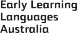

ELLA is funded by the Australian Government Department of Education, Skills and Employment and is managed by Education Services Australia. © 2021 Commonwealth of Australia, unless otherwise indicated. This material, other than Commonwealth trade marks in The Polyglots characters and The Polyglots logo, may be used in accordance with the Creative Commons BY-NC 4.0 licence unless otherwise indicated.

