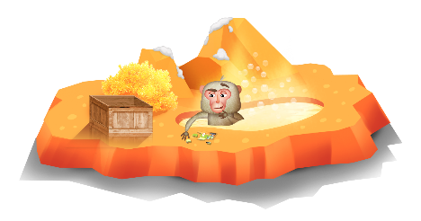
App 4: The Polyglots at the Zoo
Food puzzle
Assessment opportunities: The apps have been developed with subject matter experts. They are aligned to and support the learning outcomes of the Australian Curriculum: Languages for F–2.
You can find specific links to the Australian Curriculum for your language on the ELLA website, in the Educator Zone App Toolkit.

Health and Physical Education
Provide students with a variety of different jigsaw puzzles. These puzzles should range in difficulty (for example, in the number of pieces, puzzle image, size pf jigsaw pieces) to cater for all students. Encourage students to find feasible solutions to solving the jigsaws, and discuss tactics as a whole class.
Australian Curriculum links (Foundation): ACPPS004
English
Focus attention on the words for various types of fruit and drinks. When students are familiar with them, provide a variety of ways for them to practise writing the words in the target language. Writing in sand trays, creating words with plasticine and writing with chalk on blackboards are examples of enjoyable ways your students might do this.
Australian Curriculum links (Foundation): ACELY1651
Learning intentions: We are learning how to make requests for fruit and drinks using ________ (language).
Success criteria: I can make a request for a specific fruit and drink using ________ (language).
Resources: App 4, App 4 guide, various writing materials (such as sand trays, plasticine, chalk and blackboards), various jigsaw puzzles appropriate for your students, toy fruits and drinks, toy money or till, A3 poster paper, coloured paper
Visual Arts
Explore the still-life paintings of fruit by French artist Paul Cézanne. Explain to your students that they are going to create their own version of a Cézanne still-life painting using a range of coloured paper pieces to represent the different types of fruit.
Australian Curriculum links (Foundation): ACAVAM108 and ACAVAM109
English
Provide students with a range of toy fruits and drinks and set up an area where they can play ‘pretend’ shops. Encourage students to use the target language for the phrases – for example, ‘I’d like an apple’ or ‘I’d like some juice’. Students could also play with toy money and start to explore the value of coins.
Australian Curriculum links (Foundation): ACELY1784
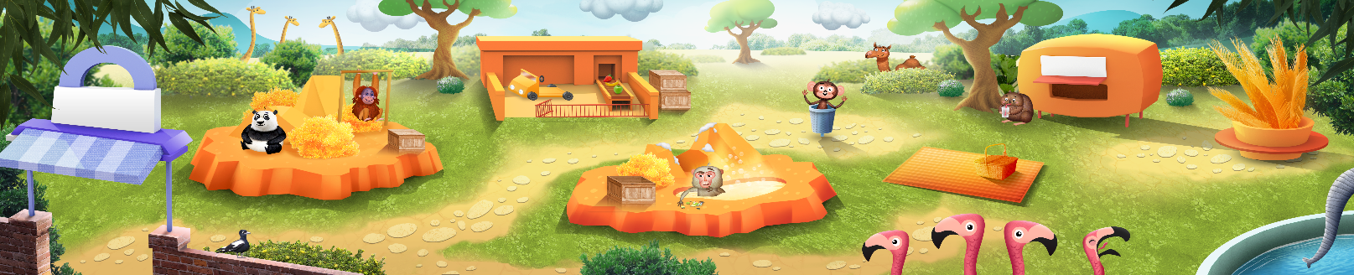

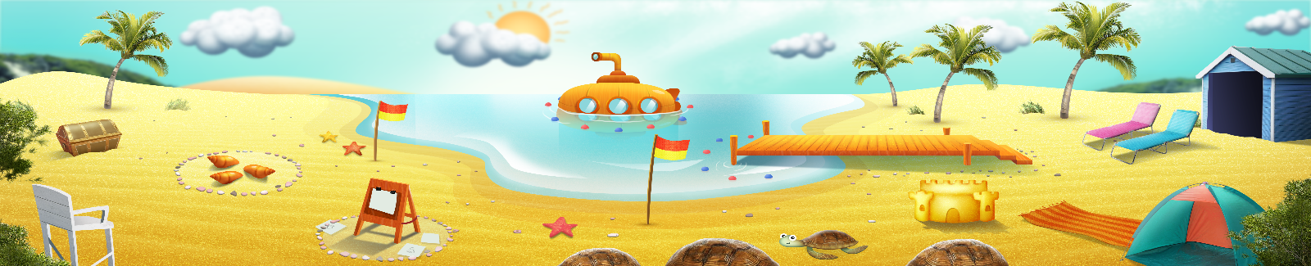


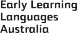

ELLA is funded by the Australian Government Department of Education, Skills and Employment and is managed by Education Services Australia. © 2021 Commonwealth of Australia, unless otherwise indicated. This material, other than Commonwealth trade marks in The Polyglots characters and The Polyglots logo, may be used in accordance with the Creative Commons BY-NC 4.0 licence unless otherwise indicated.

