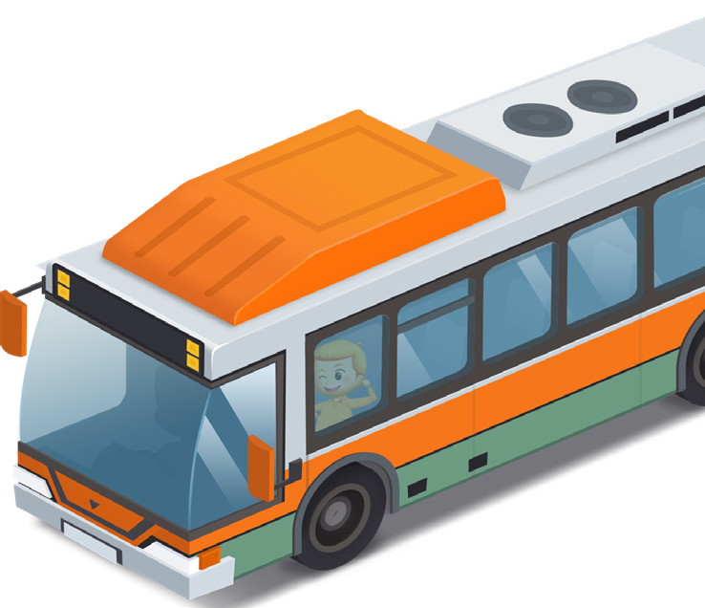
App 8: The Polyglots go to School
School bus
Learning intentions: We are learning to introduce ourselves in ___________________ (language).
Success criteria: I can say hello and use a culturally appropriate greeting using ______________ (language).
Resources: App 8, character poster (available on the ELLA website in the Educator Zone App Toolkit), graph paper, building/craft materials
English: Introduce students to the new, school-aged Polyglots characters using the character poster.
Talk about phrases we might use when we meet and greet people. What gestures do we use? Are any gestures culturally specific?
Encourage students to practise self-introductory phrases, such as those used by the characters as they board the bus, using the target language.
Australian Curriculum links (Year 1): ACELA1444
English: Students create their own narrative texts about the characters and their journey to school.
You could ask prompt questions such as: ‘What is their home like?’, ‘How are they feeling?’, ‘What are they looking forward to doing at school?’
Australian Curriculum links (Year 1): ACELY1661 and ACELT1586
English, Mathematics and Health: As a whole class, discuss possible reasons why the characters need to travel to school by bus. Ask students to talk about their own journeys to/from school.
You could do a class survey and graph the responses. You could also do a whole-class investigation into ways in which children from other countries travel to school.
Australian Curriculum links (Year 1): ACELT1582, ACMSP263 and ACPPS024
Design and Technology: Students build a 3-D version of the town using different building materials.
As a whole class, create a list of road signs seen as the characters travel to school. Students can create their own signs in their town construction, using the target language where possible.
Australian Curriculum links (Year 1): ACTDEP007
Assessment opportunities: The apps have been developed with subject matter experts. They are aligned
to and support the learning outcomes of the Australian Curriculum: Languages for F–2.
Specific links to the Australian Curriculum for your language can be found on the ELLA website, in the
Educator Zone App Toolkit.

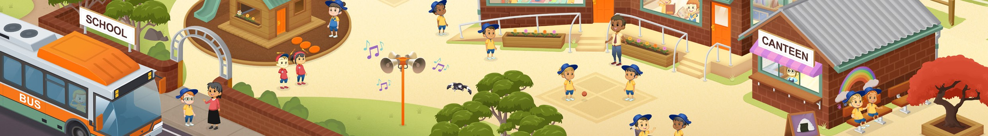

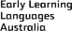
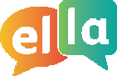
ELLA is funded by the Australian Government Department of Education, Skills and Employment and is managed by Education Services Australia. © 2020 Commonwealth of Australia, unless otherwise indicated. This material, other than Commonwealth trade marks in The Polyglots characters and The Polyglots logo, may be used in accordance with the Creative Commons BY-NC 4.0 licence unless otherwise indicated.

