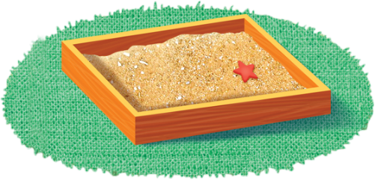
App 1: The Polyglots in the Playroom
Sandpit
English
Give students a piece of paper with the target language for ‘hello’ written on it in very large, wide letters/characters. Also provide a container full of pre-cut small squares of coloured paper. Students then choose enough paper squares for the activity of gluing them onto each of the letters/characters, to create a mosaic-like word.
Australian Curriculum links (Foundation): ACELY1651

English
Work with students to write ‘hello’ in the target language. Encourage them to make connections between writing in English and writing in the target language. Students can become familiar with forming letters/words in the target language by writing in a tray of sand.
Australian Curriculum links (Foundation): ACELY1651
Learning intentions: We are learning to recognise and say the word ‘hello’ in _______ (language).
Success criteria: I can say hello and introduce myself in _______ (language).
Resources: App 1, App 1 guide, App 1 Language and cultural guide, sandpit or sand tray, A3 paper, coloured paper squares (pre-cut), craft glue
Humanities and Social Sciences
Referring to the App 1 Language and cultural guide, use the internet to introduce students to various cultural elements of the main country or countries where your ELLA language is spoken. Talk about the various arts, foods and sports and look at similarities and differences in the way people live.
Australian Curriculum links (Foundation): ACHASSK015
Visual Arts
Students may like to create a puppet of themselves and use it to introduce themselves to the Polyglots characters – speaking the target language.
Australian Curriculum links (Foundation): ACAVAM108

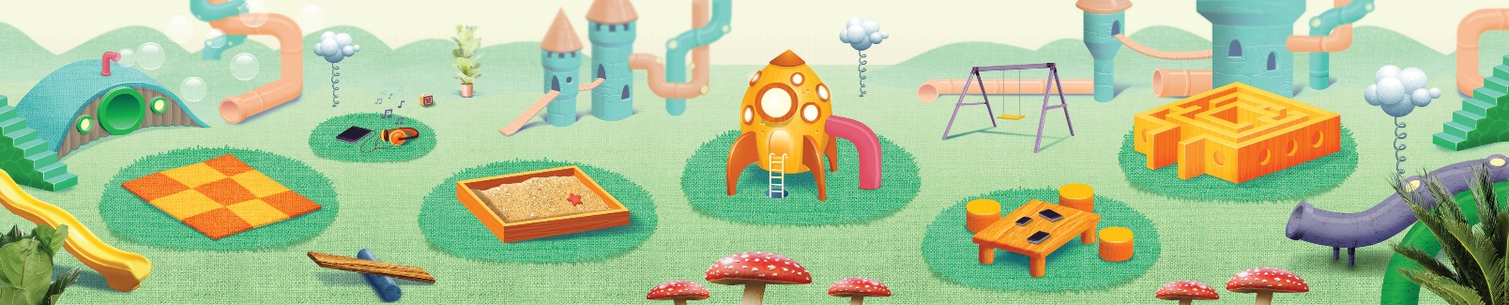
Assessment opportunities: The apps have been developed with subject matter experts. They are aligned to and support the learning outcomes of the Australian Curriculum: Languages for F–2.
You can find specific links to the Australian Curriculum for your language on the ELLA website, in the Educator Zone App Toolkit.


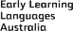
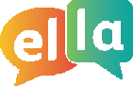
ELLA is funded by the Australian Government Department of Education, Skills and Employment and is managed by Education Services Australia. © 2021 Commonwealth of Australia, unless otherwise indicated. This material, other than Commonwealth trade marks in The Polyglots characters and The Polyglots logo, may be used in accordance with the Creative Commons BY-NC 4.0 licence unless otherwise indicated.

