
App 4: The Polyglots at the Zoo
Picnic
Assessment opportunities: The apps have been developed with subject matter experts. They are aligned to and support the learning outcomes of the Australian Curriculum: Languages for F–2.
You can find specific links to the Australian Curriculum for your language on the ELLA website, in the Educator Zone App Toolkit.

Drama
Students use the ‘Polyglots toys template’ printable to replicate the actions and responses of the Polyglot characters. Encourage them to use the phrases ‘I’m hungry,’ ‘I’m thirsty’, and make requests such as ‘I’d like an apple, please’. Students then work together to create a short role-play using as much of the language as possible, including revision language from previous apps; for example, greetings and saying thank you.
Australian Curriculum links (Foundation): ACADRM027
Visual Arts
In this experience, the fruit is placed on a plate decorated with a traditional pattern from a country where the language is spoken. Provide materials for students to re-create a ‘cultural plate’, focusing on patterns and colours significant in the country or countries where the language is spoken.
Australian Curriculum links (Foundation): ACAVAM108
Learning intentions: We are learning how to say ‘I’m hungry’/‘I’m thirsty’ in ________ (language).
Success criteria: I can say ‘I’m hungry’/‘I’m thirsty’ in ________ (language).
Resources: App 4, App 4 guide, ‘Polyglots toys template’ printable, ‘Hungry, thirsty, delicious poster’ printable, ‘Everyday ELLA ideas for cooking’ printable from the ELLA website’s public page ‘Support for families’ section, A3 paper and plain white paper plates
Health and Physical Education
This experience includes different types of drinks. Generate a discussion about healthy drink options. What is a healthy drink choice? Why are some fruit drinks bad for you? Discuss the consequences of consuming too much sugar; what effect/s does this have on our bodies? Students may like to create posters to demonstrate their understandings.
Australian Curriculum links (Foundation): ACPPS006
English
Many cultures enjoy eating different types of food, particularly at picnics and celebrations. Explore some of the cultural dishes in the country or countries where your target language is spoken. Students may like to illustrate some of their favourite dishes. You could also refer to the ‘Everyday ELLA ideas for cooking’ printable.
Australian Curriculum links (Foundation): ACELY1646
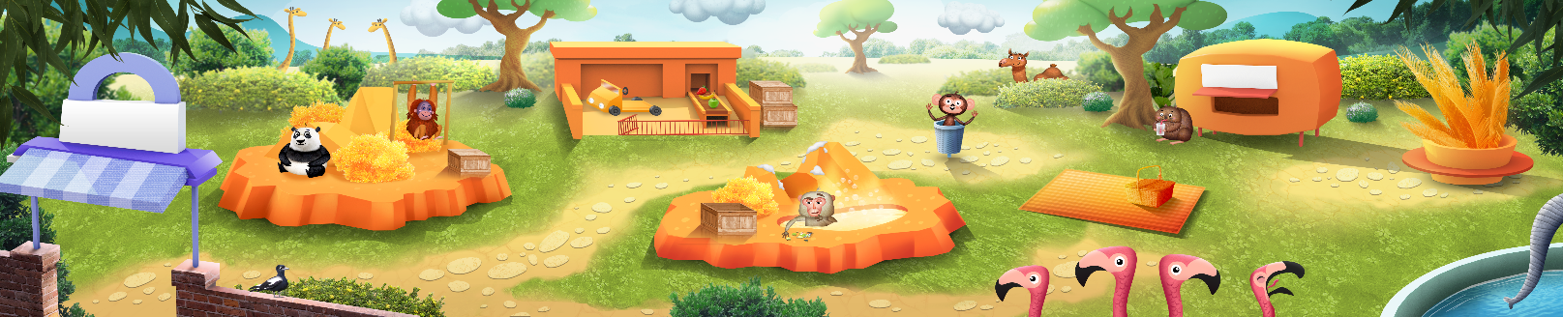

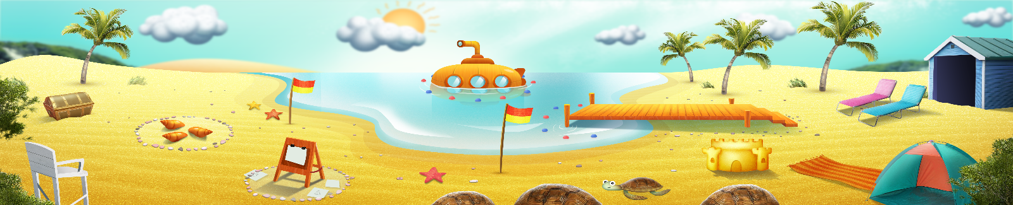


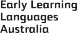

ELLA is funded by the Australian Government Department of Education, Skills and Employment and is managed by Education Services Australia. © 2021 Commonwealth of Australia, unless otherwise indicated. This material, other than Commonwealth trade marks in The Polyglots characters and The Polyglots logo, may be used in accordance with the Creative Commons BY-NC 4.0 licence unless otherwise indicated.

