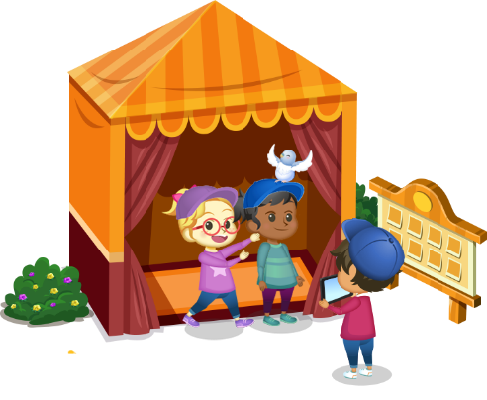
App 10: The Polyglots at the Pet Park
Photo booth
Learning intentions: We are learning how to describe emotions in ___________________ (language).
Success criteria: I can describe different emotions in _____________ (language).
Resources: App 10, App 10 guide, A3 paper, scissors, glue
English; Visual Arts; Health and Physical Education
Using the adjectives happy, sad, tired, hungry and thirsty, students can create a poster with five columns, each containing one adjective traced/copied/written in the target language as the title for each column. Students draw or write when they feel these emotions under the correct column. Alternatively, students create a separate poster for each emotion and include when other people or their pets may feel these emotions.
Australian Curriculum links (Year 2): ACELY1671, ACAVAM108 and ACPPS020
English
Generate a whole-class discussion about the history of photograph. Discuss how the process has changed over time. What are the differences? How has technology changed? Students may like to create a timeline and record some of the significant changes.
Australian Curriculum links (Year 2): ACELY1789
Assessment opportunities: The apps have been developed with subject matter experts. They are aligned
to and support the learning outcomes of the Australian Curriculum: Languages for F–2.
You can find specific links to the Australian Curriculum for your language on the ELLA website, in the
Educator Zone App Toolkit.

English; Drama
The Photo booth activity contains the adjectives for happy, sad, tired, hungry and thirsty in the target language. As a whole class, practise the pronunciation of these words and their meanings. In pairs or small groups, students can practise the meaning of these words by acting them out. Students can then choose one word to act out for their classmates to guess the word and call it out in the target language.
Australian Curriculum links (Year 2): ACELY1666; ACADRM028
English
Using the content from the App 10 guide, create a set of cards that students in pairs can use to play games of Memory. Half of the cards would have an image from the Photo booth learning experience, taken from each emotional state of the animals. The other half could contain an associated adjective in the target language. Students practise writing the words by tracing/copying/writing the words onto the cards themselves.
Australian Curriculum links (Year 2): ACELY1671

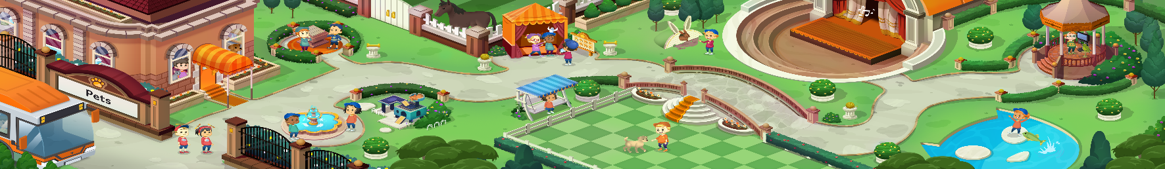


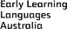

ELLA is funded by the Australian Government Department of Education, Skills and Employment and is managed by Education Services Australia. © 2021 Commonwealth of Australia, unless otherwise indicated. This material, other than Commonwealth trade marks in The Polyglots characters and The Polyglots logo, may be used in accordance with the Creative Commons BY-NC 4.0 licence unless otherwise indicated.

