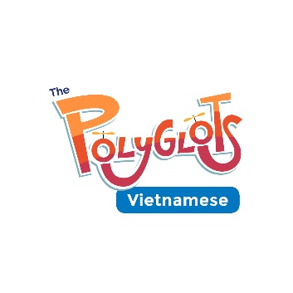
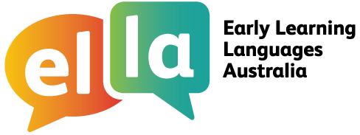

Things I can do in Vietnamese
I have been learning Vietnamese using The Polyglots apps.

Here are some of the things I can do in the language:
Doing sometimes Beginning to do Regularly doing with assistance independently confidently

App 1: The Polyglots in the Playroom
I can sing a song in Vietnamese
I can say some simple greetings in Vietnamese
I can introduce myself in Vietnamese

App 2: The Polyglots at the Beach

I can name some colours in Vietnamese
I understand some simple instructions in Vietnamese
I can express some likes and dislikes in Vietnamese

App 3: The Polyglots at the Birthday Party

I can count to 10 in Vietnamese
I can say how old I am in Vietnamese
I can say happy birthday in Vietnamese

App 4: The Polyglots at the Zoo

I can name some fruits in Vietnamese
I can say I'm hungry/thirsty in Vietnamese
I can say thank you in Vietnamese
I can make simple requests in Vietnamese

App 5: The Polyglots at the Circus

I can name some body parts in Vietnamese
I can say some parts of the face in Vietnamese
I can say something hurts in Vietnamese
I can use some adjectives in Vietnamese (eg big/small)

App 6: The Polyglots at the Park
I can respond to some simple instructions in Vietnamese using action words
I can name some shapes in Vietnamese
I can recognise the meaning of some words written in Vietnamese
I can say goodbye in Vietnamese
App 7: The Polyglots in the Town
I can give some simple instructions in Vietnamese using action words
I can use some adverbs in Vietnamese (eg quickly/slowly)

