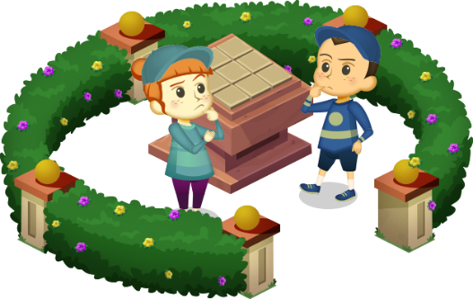
App 10: The Polyglots at the Pet Park
Animal scrambler
Learning intentions: We are learning how to name types of pets in ___________________ (language).
Success criteria: I can identify different types of pets in ___________________ (language).
Resources: App 10, App 10 guide, animal images, scissors, glue, A3 poster paper, counters, graph/grid paper, colour pencils
Mathematics
The Animal scrambler learning experience includes two puzzle boards in different sizes. Explore the concept of multiplication as repeated addition and arrays. Provide students with counters and grid paper to encourage them to create different arrays and ways to find the total number of squares. They can record their results onto graph/grid paper and colour and record the size of the boards; e.g. 3 + 3 + 3 = 9, 3 x 3 = 9
Australian Curriculum links (Year 2): ACMNA031

English; Visual Arts
The Animal scrambler learning experience contains the names of types of pets in the target language. Following this activity, students can produce a display poster by illustrating their own choice of pets and trace/copy/write the name of the animal using the target language.
Australian Curriculum links (Year 2): ACELY1671 and ACAVAM108

Visual Arts
Students can create their own puzzles to unscramble. Students may like to draw on their knowledge from earlier apps and create puzzles that include fruit (App 4) or school items (App 8), for example.
Australian Curriculum links (Year 2): ACAVAM108
Assessment opportunities: The apps have been developed with subject matter experts. They are aligned
to and support the learning outcomes of the Australian Curriculum: Languages for F–2.
You will find specific links to the Australian Curriculum for your language on the ELLA website, in the
Educator Zone App Toolkit.
Visual Arts
Provide students with templates which contain faint ruled lines for either a 3 x 3 puzzle or a 4 x 4 puzzle. Students can draw and colour an animal as they wish. They can label their animal using the target language. Stick completed drawings onto thicker paper, let dry and then carefully cut out each square to form the puzzle tiles. Students can then recreate the Animal scrambler activity and take it in turns to complete different puzzles.
Australian Curriculum links (Year 2): ACAVAM108

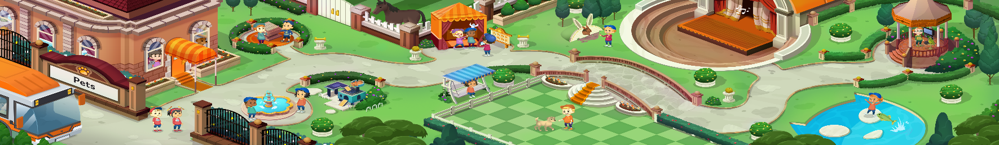


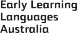

ELLA is funded by the Australian Government Department of Education, Skills and Employment and is managed by Education Services Australia. © 2021 Commonwealth of Australia, unless otherwise indicated. This material, other than Commonwealth trade marks in The Polyglots characters and The Polyglots logo, may be used in accordance with the Creative Commons BY-NC 4.0 licence unless otherwise indicated.

